MACHINE LEARNING PORTFOLIO · MSC DATA SCIENCE · ARDEN UNIVERSITY BERLIN
Product Segmentation and Performance Clustering for an E-Commerce Fragrance Marketplace
An end-to-end unsupervised machine learning investigation comparing K-Means, Ward hierarchical clustering, DBSCAN, HDBSCAN and the TabClustPFN foundation model across 1,000 marketplace listings, translated into evidence-based actions for catalogue strategy.

STUDENT ID | 25199053
MODULE | COM7022 Machine Learning · Assignment [5444]
ASSESSMENT | Portfolio · Task 1 Practical Project · Task 2 Critical Report
WORD COUNT | 3,319 words of body text (Task 1: 2,372 · Task 2: 947); captions, tables, figures, code screenshots, references and appendix excluded
DATASET | Sales-[5444].csv · 1,000 listings × 10 attributes
REPOSITORY | https://github.com/kvmmn/_COM7022_MachineLearning
REVIEW PORTAL | https://kvmmn.github.io/_COM7022_MachineLearning/

CORE REVENUE ENGINE  92.3%  of units sold come from 24.3% of listings (Cluster 2) | INVENTORY RISK  31.3%  of listings sit in the low-stock tail (Cluster 3) | MODEL STABILITY  0.932  K-Means bootstrap ARI over 30 resamples | PCA VARIANCE  78.7%  retained by the first two components

Every figure, table and code screenshot carries a caption that names and links its exact file in the GitHub repository.

Contents
1. Introduction | 3
1.1 Business Context | 3
1.2 The Dataset | 3
1.3 Problem Statement | 3
1.4 Project Objectives | 3
1.5 Methodological Approach | 3
TASK 1 · PRACTICAL MACHINE LEARNING INVESTIGATION
2. Data Preparation | 5
2.1 Data Quality Audit | 5
2.2 Cleaning Strategy | 6
2.3 Transformation, Scaling and Categorical Variables | 9
2.4 Feature Selection | 11
3. Model Selection | 11
3.1 Clustering in Brief | 11
3.2 Candidate Techniques | 12
3.3 Dimensionality Reduction with PCA | 12
4. Model Implementation and Evaluation | 13
4.1 K-Means | 13
4.2 Hierarchical Clustering | 14
4.3 DBSCAN | 15
4.4 HDBSCAN | 16
4.5 TabClustPFN | 17
4.6 Evaluation Framework | 17
4.7 Comparative Results | 18
5. Cluster Characteristics | 19
TASK 2 · CRITICAL REPORT FOR EXECUTIVE STAKEHOLDERS
6. Executive Summary | 22
7. Critical Evaluation | 22
7.1 Suitability of the Methods and Design Decisions | 22
7.2 Comparative Performance: Strengths and Limitations | 22
7.3 Why K-Means Is the Right Choice for E-Commerce | 23
8. Recommendations for Business Managers | 23
9. Limitations | 24
10. Conclusion and Future Work | 24
References | 25
Appendix A: Reproducible Code | 26

1. Introduction

1.1 Business Context
This portfolio is written as a newly appointed Machine Learning Analyst at a rapidly growing multi-seller e-commerce marketplace. Independent merchants list competing offers for the same products, so the catalogue grows faster than any team can curate by hand. Decisions on which listings to promote, replenish or retire now require a scalable, data-driven view.

1.2 The Dataset
The analysis uses the company extract Sales-[5444].csv: 1,000 listings described by 10 attributes covering product identity (Item_Name, details, Catatory), pricing (price, priceWithCurrency), availability and traction (available, text, sold), maintenance history (lastUpdated) and dispatch origin (itemLocation). The catalogue is a men's fragrance category, dominated by US-based sellers (909 listings) with a smaller cross-border segment led by Hong Kong (52). Critically, each row is a seller listing rather than a unique product: the same fragrance can appear several times at different prices and stock positions, so the resulting segments describe commercial offers, not manufacturers.

1.3 Problem Statement
Three obstacles prevent the company from managing this catalogue strategically. First, scale: manual review cannot keep pace with listing growth. Second, data quality: prices and sales are partly stored as free text, category labels are inconsistent and the platform censors stock above ten units. Third, the absence of labels: no field states whether a listing is a best-seller, a premium niche item or an inventory risk, which rules out supervised learning. The business question is therefore one of discovery: what natural commercial groups exist in the catalogue, and how should each be managed?

1.4 Project Objectives
- O1 — Data readiness: audit, clean and transform the dataset with every intervention evidenced and reproducible.
- O2 — Segmentation: apply K-Means, Hierarchical (agglomerative) clustering, DBSCAN, the more recent HDBSCAN and the TabClustPFN foundation model to group listings by product characteristics and sales performance.
- O3 — Rigorous evaluation: compare models with complementary internal, stability and sensitivity measures rather than a single score.
- O4 — Model justification: select the model that is technically strongest and operationally suited to e-commerce.
- O5 — Business translation: convert segments into evidence-based actions for non-technical decision-makers.

1.5 Methodological Approach
The investigation follows a structured machine learning lifecycle (Figure 1). Each stage is implemented in a single Google Colab notebook with fixed random seeds, and every analytical decision is logged so that results can be regenerated end to end. The notebook was re-executed from a clean state before this report was written and reproduced every reported figure.
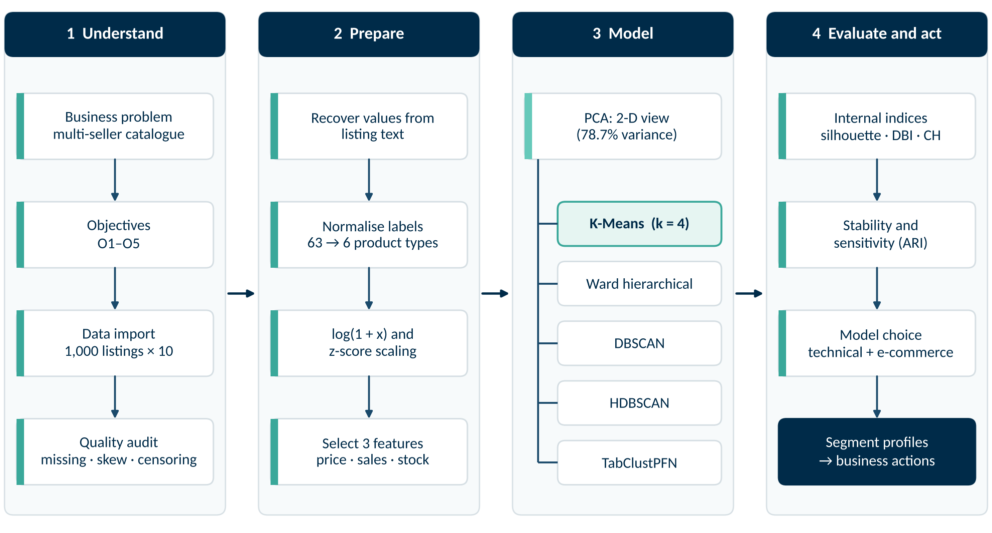
Figure 1. End-to-end methodological workflow, from business problem to recommended actions.
Source: COM7022 - Assignment/output/figures/fig15_workflow.png

TASK 1
Practical Machine Learning Investigation
2,372 words of body text

2. Data Preparation

2.1 Data Quality Audit
A systematic audit preceded any modelling. The file contains no full-row duplicates, although 34 listings repeat an identical description, consistent with multi-seller offers rather than data-entry error. Missing values affect eight columns (Table 1, Figure 2); the largest gaps are in available (111 rows, 11.1%) and lastUpdated (53 rows, 5.3%).
Descriptive profiling exposed four structural problems that would distort any distance-based algorithm:
- Extreme skew. Units sold range from 1 to 54,052 against a median of 49.5 (skewness 9.70); price is also right-skewed (2.04). Euclidean distances on raw values would be dominated by a handful of viral listings (Figure 3).
- Censored stock. The platform displays "More than 10 available" for 299 listings and stores the value as 10, so recorded stock is a ceiling, not a measurement.
- Label fragmentation. Catatory holds 63 distinct strings that are largely spelling and capitalisation variants of a few fragrance types.
- Mixed currency. Three prices are quoted in Canadian dollars.
Table 1. Missing values per attribute in the raw extract (n = 1,000).
Attribute | Missing | Missing %
available | 111 | 11.1
lastUpdated | 53 | 5.3
sold | 8 | 0.8
price | 5 | 0.5
text | 3 | 0.3
Catatory | 3 | 0.3
priceWithCurrency | 1 | 0.1
Item_Name | 1 | 0.1
Source: COM7022 - Assignment/output/tables/table01_missing_values.csv
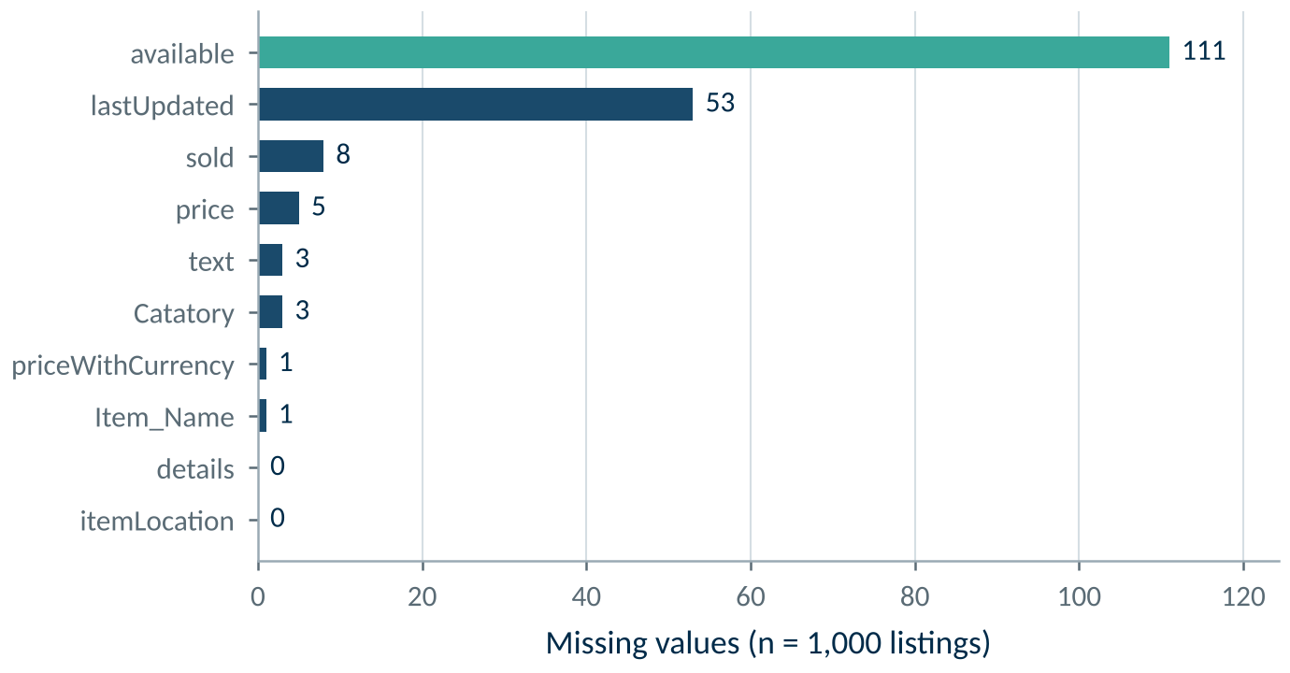
Figure 2. Missing values by attribute in the raw extract.
Source: COM7022 - Assignment/output/figures/fig01_missing_values.png
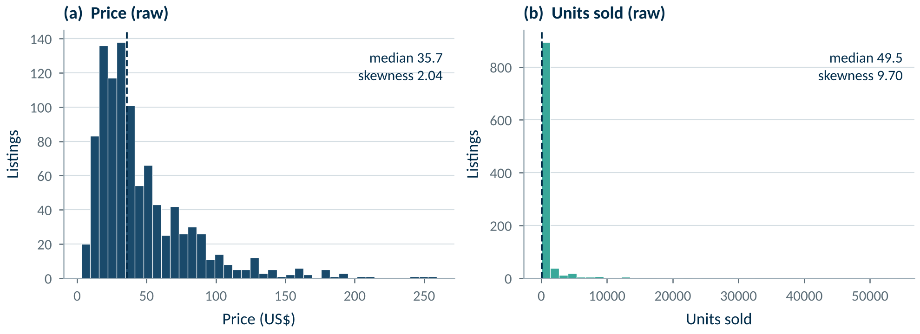
Figure 3. Raw distributions of price and units sold, showing the extreme right skew.
Source: COM7022 - Assignment/output/figures/fig02_raw_distributions.png

2.2 Cleaning Strategy
Preparation followed a single principle: recover before you impute. Where a value was absent, it was first reconstructed from another field of the same listing; statistical imputation was used only where the cause of the gap was understood, and it was always flagged. Every step was recorded in an execution log (Table 2) and the overall flow is summarised in Figure 4.
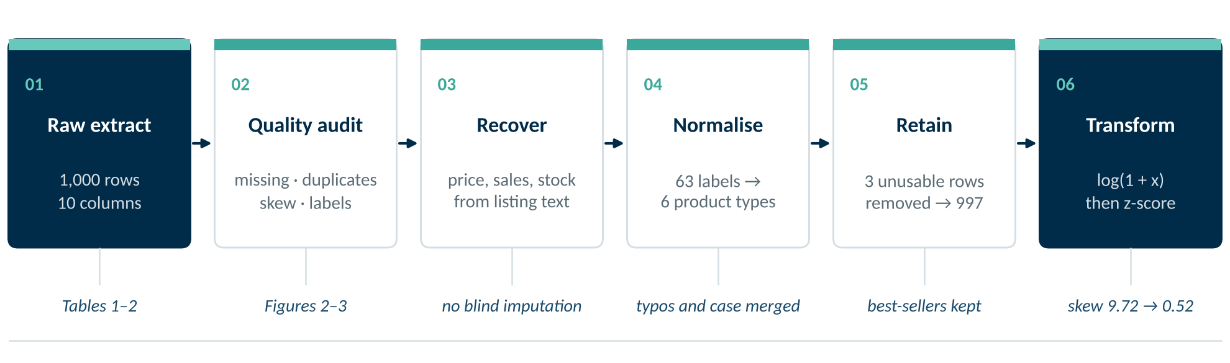
Figure 4. Data preparation pipeline from the raw extract to model-ready features.
Source: COM7022 - Assignment/output/figures/fig16_data_prep_flow.png
- Price and sales recovery. All five missing prices were restored from priceWithCurrency, which matched the numeric field exactly in all 994 rows holding both. Two sales figures were parsed from text; three listings showing stock but no sales were set to zero; Canadian prices were converted at a documented rate.
- Stock reconstruction. Availability was rebuilt from listing wording: "More than 10" and any explicit value above ten were coded as 11 (well stocked), "Last One" as 1, and the 62 "Limited quantity" or lot listings received the median with an indicator column, so their influence could be audited.
- Category normalisation. The 63 raw labels were consolidated into six coherent product types (Eau de Toilette, Eau de Parfum, Cologne, Parfum/Extrait, Generic fragrance, Other).
- Record retention. Only three listings with neither sales nor stock information were removed, leaving 997 verified listings. No commercially extreme listing was discarded, because best-sellers are precisely the observations the business must understand.
Table 2. Execution log of every cleaning and transformation step.
Pre-processing step | Rows affected | Rationale
Recover price from priceWithCurrency | 5 | Exact same value, only stored in text form
Convert CAD prices to USD | 3 | Fixed rate 0.73, documented approximation
Recover sold from text | 2 | Exact value from the listing wording
Set sold = 0 where text shows stock but no sales | 3 | Listing wording omits 'sold' when nothing has sold
Drop rows with no sales or stock information | 3 | Cannot be placed on the sales-performance axis
Stock: 'More than 10' coded as 11 | 299 | Censored value, not exact
Stock: explicit values above 10 capped at 11 | 115 | Same scale as the censored rows
Stock: 'Last One' coded as 1 | 47 | Wording means one unit left
Stock: median imputation | 62 | Limited quantity / lot wording; flagged in stock_imputed
Collapse category labels into 6 product types | 994 | Case, spelling and wording variants
Missing brand set to 'Unbranded' | 1 | Single row
Log-transform price and sold | 997 | Outliers kept; log scale limits their pull on distances
Source: COM7022 - Assignment/output/tables/table03_cleaning_log.csv
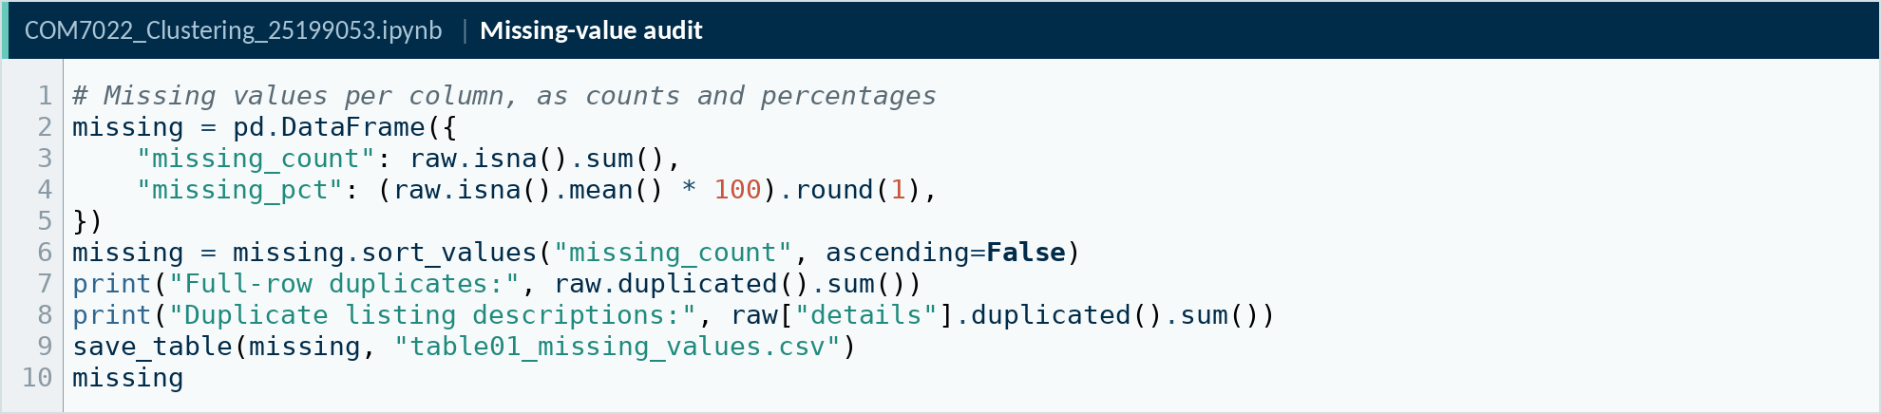
Figure 5. Code screenshot: Missing-value and duplicate audit.
Source: COM7022 - Assignment/output/screenshots/code02_missing_values.png
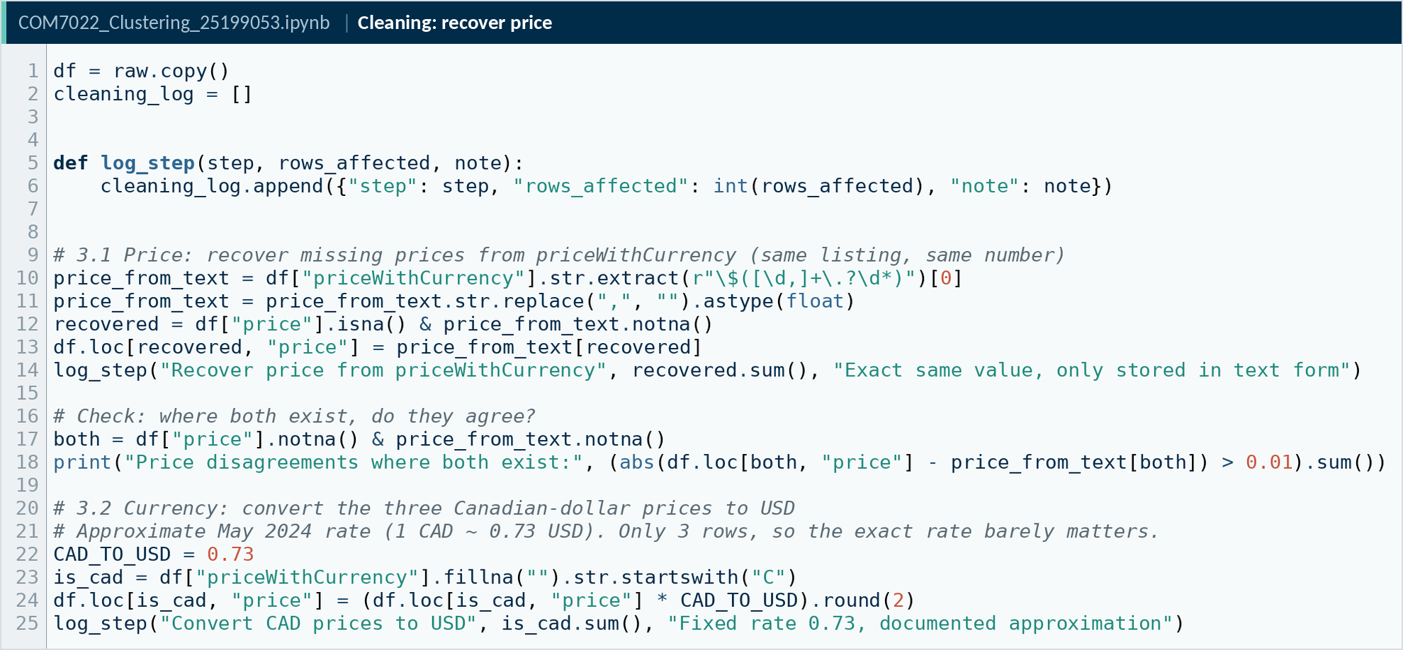
Figure 6. Code screenshot: Recovery of price from priceWithCurrency and currency conversion.
Source: COM7022 - Assignment/output/screenshots/code03_price_recovery.png
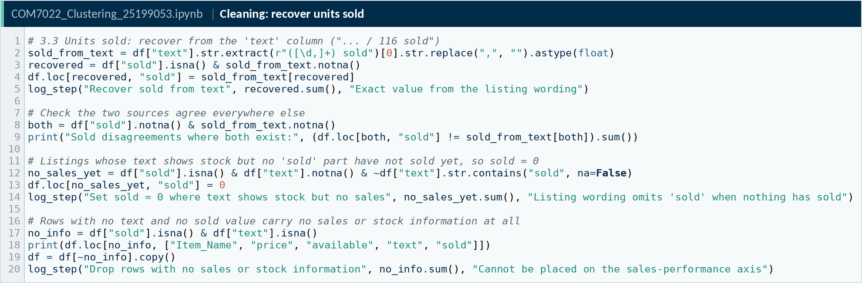
Figure 7. Code screenshot: Recovery of units sold from the listing text.
Source: COM7022 - Assignment/output/screenshots/code04_sold_recovery.png
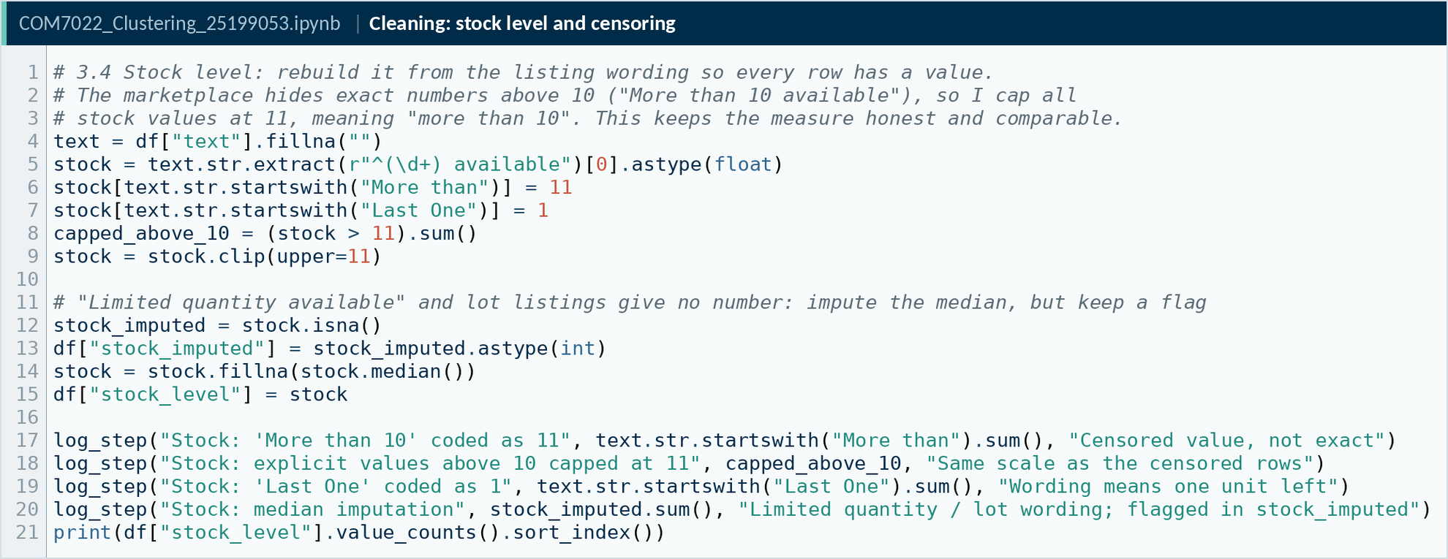
Figure 8. Code screenshot: Stock reconstruction and treatment of censoring.
Source: COM7022 - Assignment/output/screenshots/code05_stock_level.png
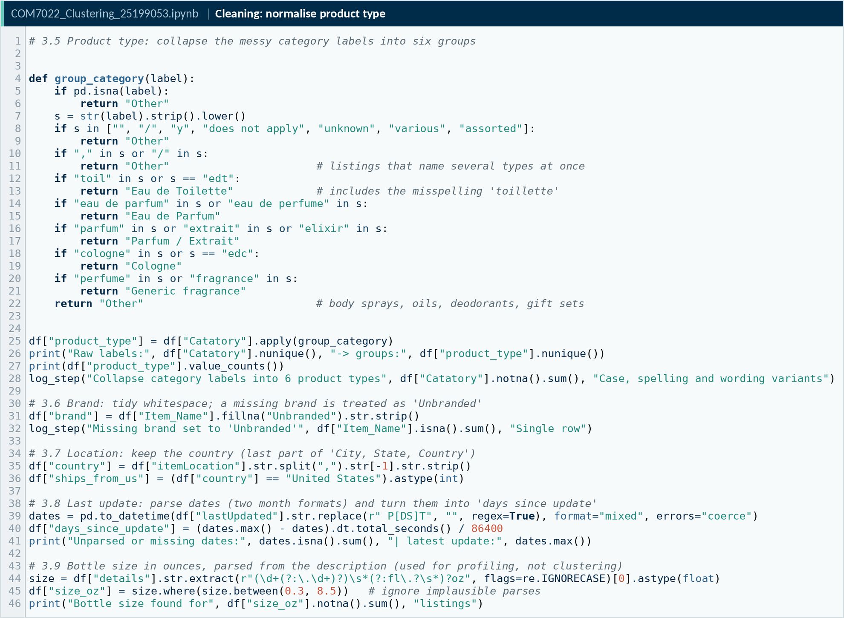
Figure 9. Code screenshot: Normalisation of 63 category labels into six product types.
Source: COM7022 - Assignment/output/screenshots/code06_product_type.png

2.3 Transformation, Scaling and Categorical Variables
Logarithmic transformation. A log(1 + x) transform was applied to price and units sold. It preserves zero values and rank order while compressing the long right tail, reducing the skewness of units sold from 9.72 to 0.52 and of price from 1.97 to 0.09 (Table 3, Figure 10).
Standardisation. Because all three algorithms rely on Euclidean distance, each feature was converted to a z-score so that it contributes equal variance:
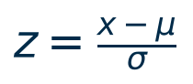

Min-max normalisation was evaluated as an alternative and rejected: it inflates the bounded 1–11 stock scale relative to the log-transformed measures and changed the partition substantially (ARI 0.49; Section 4.7).
Categorical variables. Brand (246 values), product type and country were deliberately excluded from the distance computation. One-hot encoding would add hundreds of sparse dimensions and allow single brands to dominate the geometry; these attributes were instead reserved for post-hoc cluster profiling.
Table 3. Descriptive statistics of the 997 cleaned listings before and after the log transform.
Variable | Mean | Std | Min | Median | Max | Skewness
price (US$) | 46.07 | 34.75 | 3 | 35.62 | 259.09 | 1.97
units sold | 771.63 | 3203.77 | 0 | 49 | 54,052 | 9.72
stock level | 7.73 | 3.53 | 1 | 9 | 11 | -0.57
log price | 3.63 | 0.67 | 1.39 | 3.6 | 5.56 | 0.09
log units sold | 4.29 | 2.08 | 0 | 3.91 | 10.9 | 0.52
Source: COM7022 - Assignment/output/tables/table04_descriptive_statistics_clean.csv
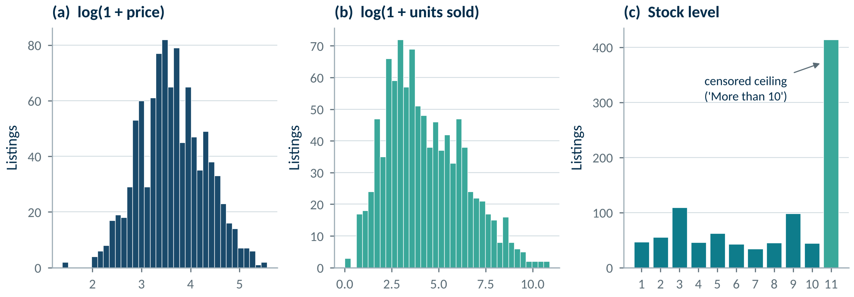
Figure 10. Feature distributions after the logarithmic transformation.
Source: COM7022 - Assignment/output/figures/fig03_transformed_distributions.png
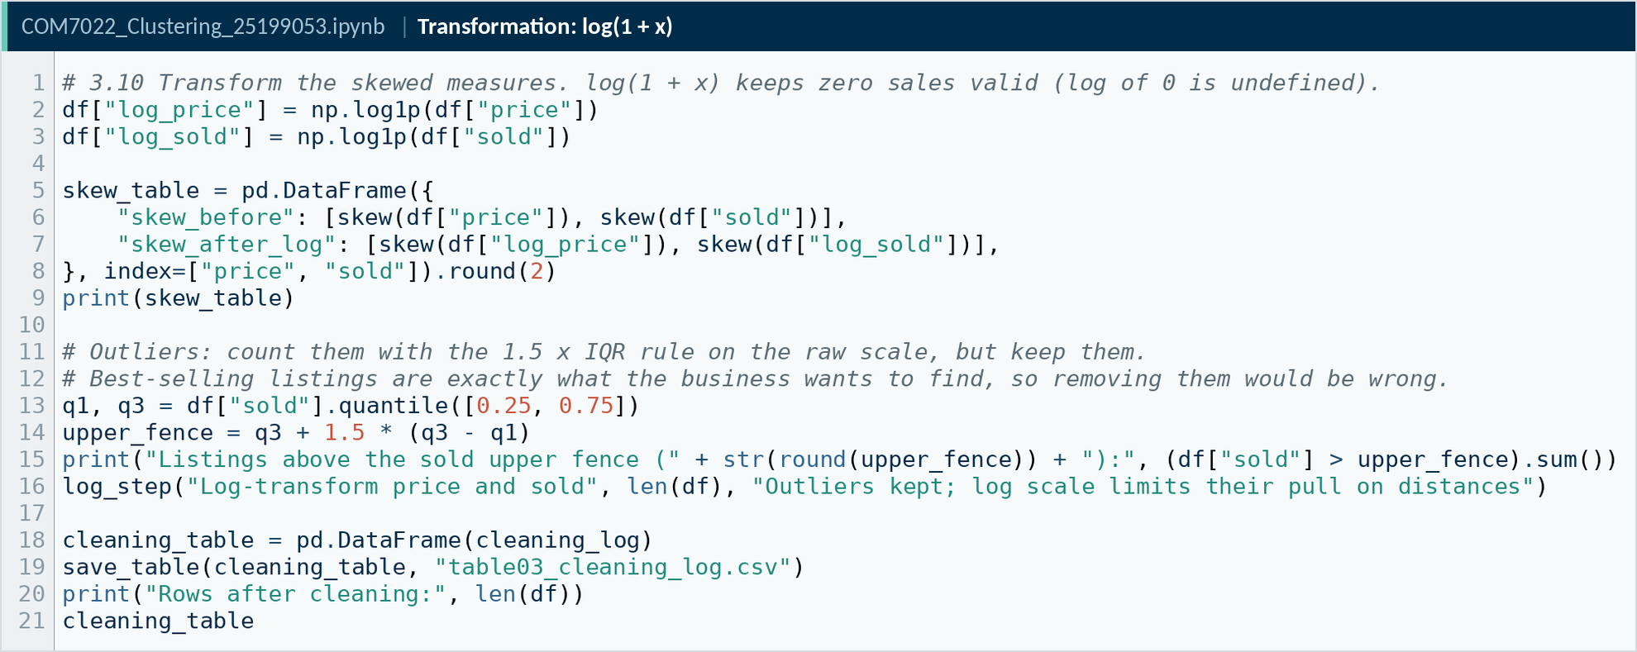
Figure 11. Code screenshot: Logarithmic transformation of skewed measures.
Source: COM7022 - Assignment/output/screenshots/code07_log_transform.png
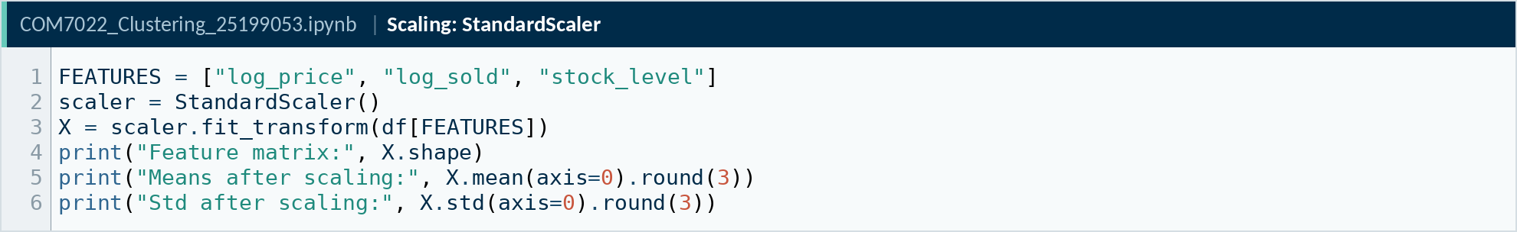
Figure 12. Code screenshot: Z-score standardisation of the selected features.
Source: COM7022 - Assignment/output/screenshots/code08_scaling.png

2.4 Feature Selection
Candidate features were screened with Spearman rank correlation (Figure 13) and a systematic comparison of five feature sets (Table 4). The correlations are weak to moderate (price–sales −0.13, price–stock −0.20, sales–stock +0.35), confirming that each candidate captures a distinct commercial mechanism without problematic collinearity.
The final set comprises log price, log units sold and stock level (Set B), representing market position, demand and supply resilience. A two-feature baseline (Set A) achieves a marginally higher silhouette but ignores availability, which is central to the brief and to stock-out risk. Adding listing recency or bottle size reduced separation without adding actionable meaning: half of all bottles fall between 3.3 and 3.7 oz, and three-quarters of listings were updated within the past week.
Table 4. K-Means silhouette scores for five candidate feature sets (higher is better).
Feature set | Features | k = 2 | k = 3 | k = 4 | k = 5 | k = 6
A: price + sold | 2 | 0.351 | 0.377 | 0.356 | 0.351 | 0.354
B: price + sold + stock | 3 | 0.337 | 0.297 | 0.307 | 0.308 | 0.297
C: B + days since update | 4 | 0.31 | 0.315 | 0.277 | 0.288 | 0.284
D: B + bottle size | 4 | 0.274 | 0.308 | 0.271 | 0.272 | 0.272
E: B + days + size | 5 | 0.256 | 0.259 | 0.292 | 0.255 | 0.258
Source: COM7022 - Assignment/output/tables/table05_feature_set_scan.csv
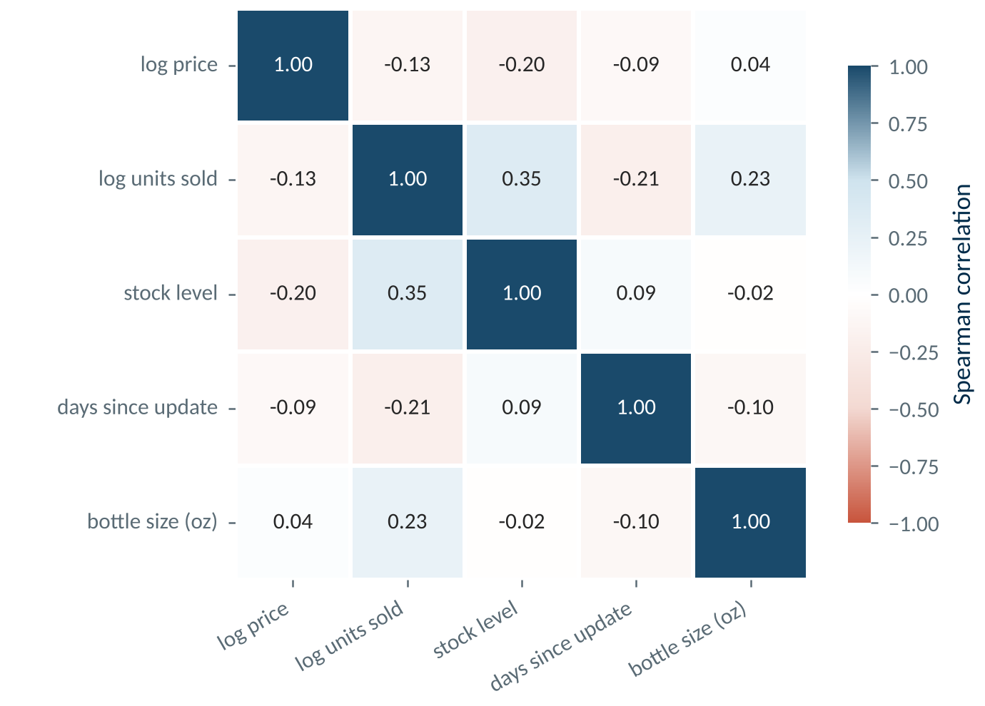
Figure 13. Spearman rank correlation between candidate features.
Source: COM7022 - Assignment/output/figures/fig04_feature_correlation.png

3. Model Selection

3.1 Clustering in Brief
Clustering is an unsupervised learning task: it partitions observations so that members of a group are more similar to one another than to members of other groups, without reference to known outcomes. It is the appropriate paradigm here because the catalogue carries no commercial labels; the objective is to reveal structure, not to predict a target.

3.2 Candidate Techniques
Five techniques were selected because they embody different definitions of a "cluster", from classical to state-of-the-art (Table 5):
- K-Means (MacQueen, 1967) is centroid-based. It minimises within-cluster variance by alternately assigning points to the nearest centroid and updating the centroids:
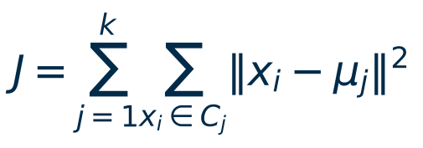

- Agglomerative hierarchical clustering builds a nested tree by repeatedly merging the closest clusters. Ward linkage (Ward, 1963) merges the pair that least increases total within-cluster variance.
- DBSCAN (Ester et al., 1996) is density-based. It grows clusters from dense neighbourhoods defined by a radius ε and a minimum point count, and labels isolated points as noise.
- HDBSCAN (Campello, Moulavi and Sander, 2013; McInnes, Healy and Astels, 2017), in scikit-learn since 2023, removes ε: it builds a hierarchy over all density levels and keeps the most persistent clusters, so it can detect groups of differing density.
- TabClustPFN (Zhao et al., 2026) is a tabular foundation model in the TabPFN family (Hollmann et al., 2025): a transformer pre-trained on synthetic clustering problems that assigns clusters, and can predict their number, in a single pass without being fitted to the data.
Table 5. Comparison of the clustering techniques applied.
Technique | Principle | Strengths | Limitations
K-Means | Centroid-based: minimises within-cluster variance | Fast, scalable, full coverage, interpretable centroids | Requires k; assumes compact, similar-sized clusters
Hierarchical (Ward) | Agglomerative: merges clusters into a dendrogram | No k needed upfront; reveals nested structure | Irreversible merges; O(n²) memory; sensitive to sampling
DBSCAN | Density-based: grows clusters from dense regions | Arbitrary shapes; explicit noise and outlier detection | Needs density gaps; sensitive to ε and MinPts
HDBSCAN | Hierarchical density: keeps the most persistent clusters across all densities | No ε; handles varying density; membership strengths | Still needs density gaps; can leave many points as noise
TabClustPFN | Pre-trained transformer: clusters the table in context, no fitting | Predicts k itself; no tuning; seconds to run | Black box; external weights; small-data context limit

3.3 Dimensionality Reduction with PCA
Principal Component Analysis (Pearson, 1901) was applied to the standardised features, not to reduce noise (there are only three inputs) but to provide a faithful two-dimensional plane for interpreting clusters. The first two components retain 78.7% of variance (Figure 14, Table 6). PC1 (48.6%) loads on sales and stock against price, measuring commercial traction; PC2 (30.1%) is dominated by price (0.91), measuring price tier.
Table 6. PCA loadings of the standardised features.
Feature | PC1 (48.6%) | PC2 (30.1%) | PC3 (21.3%)
log_price | -0.421 | 0.906 | 0.051
log_sold | 0.636 | 0.335 | -0.695
stock_level | 0.647 | 0.26 | 0.717
Source: COM7022 - Assignment/output/tables/table06_pca_loadings.csv
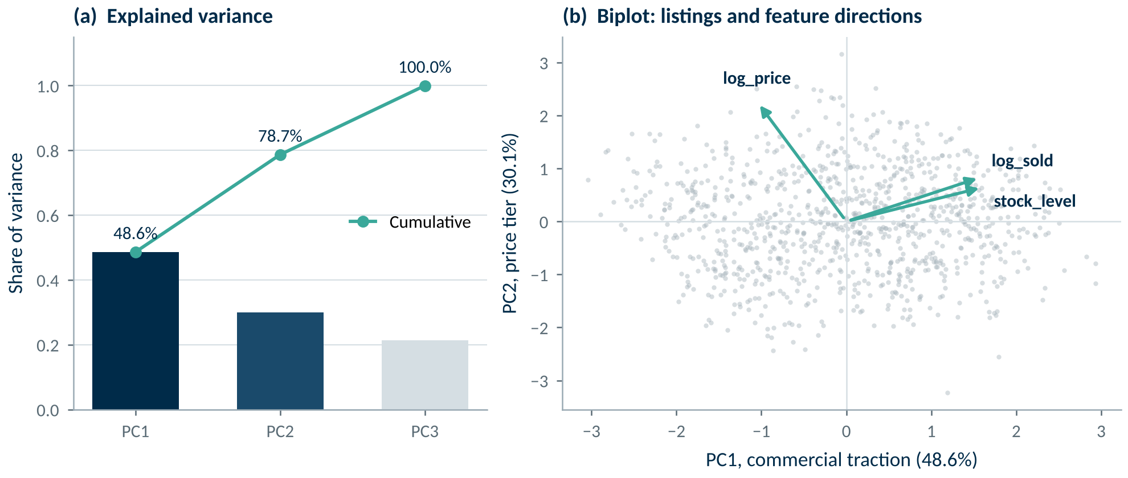
Figure 14. Explained variance (left) and loading biplot (right) of the principal components.
Source: COM7022 - Assignment/output/figures/fig05_pca_variance_biplot.png

4. Model Implementation and Evaluation

4.1 K-Means
K-Means was fitted with k-means++ initialisation, 20 restarts and a fixed seed (42) for k = 2 to 10 (Table 7, Figure 15). Inertia falls by 38.9% from k = 2 to k = 4 and flattens thereafter. The silhouette peaks at k = 2 (0.337), but a two-way split merely separates high from low volume. k = 4 achieves the lowest Davies-Bouldin index (1.015) with a solid silhouette (0.307) and segments of 22–31% of listings. All four clusters have positive mean silhouette widths (0.29–0.32) and only 1.0% of listings carry a negative value (Figure 16).
Table 7. K-Means model scan for k = 2 to 10.
k | Inertia | Silhouette ↑ | Davies-Bouldin ↓ | Calinski-Harabasz ↑ | Smallest cluster
2 | 1943 | 0.337 | 1.211 | 536.7 | 393
3 | 1501 | 0.297 | 1.228 | 493.4 | 298
4 | 1186.7 | 0.307 | 1.015 | 503.3 | 219
5 | 974.4 | 0.308 | 1.018 | 513.3 | 156
6 | 862.5 | 0.297 | 1.053 | 489.1 | 141
7 | 766.7 | 0.307 | 1.043 | 478.7 | 84
8 | 691.8 | 0.296 | 1.057 | 469.6 | 82
9 | 640.9 | 0.296 | 1.029 | 452.9 | 59
10 | 594.6 | 0.294 | 1.037 | 442 | 53
Source: COM7022 - Assignment/output/tables/table07_kmeans_k_scan.csv
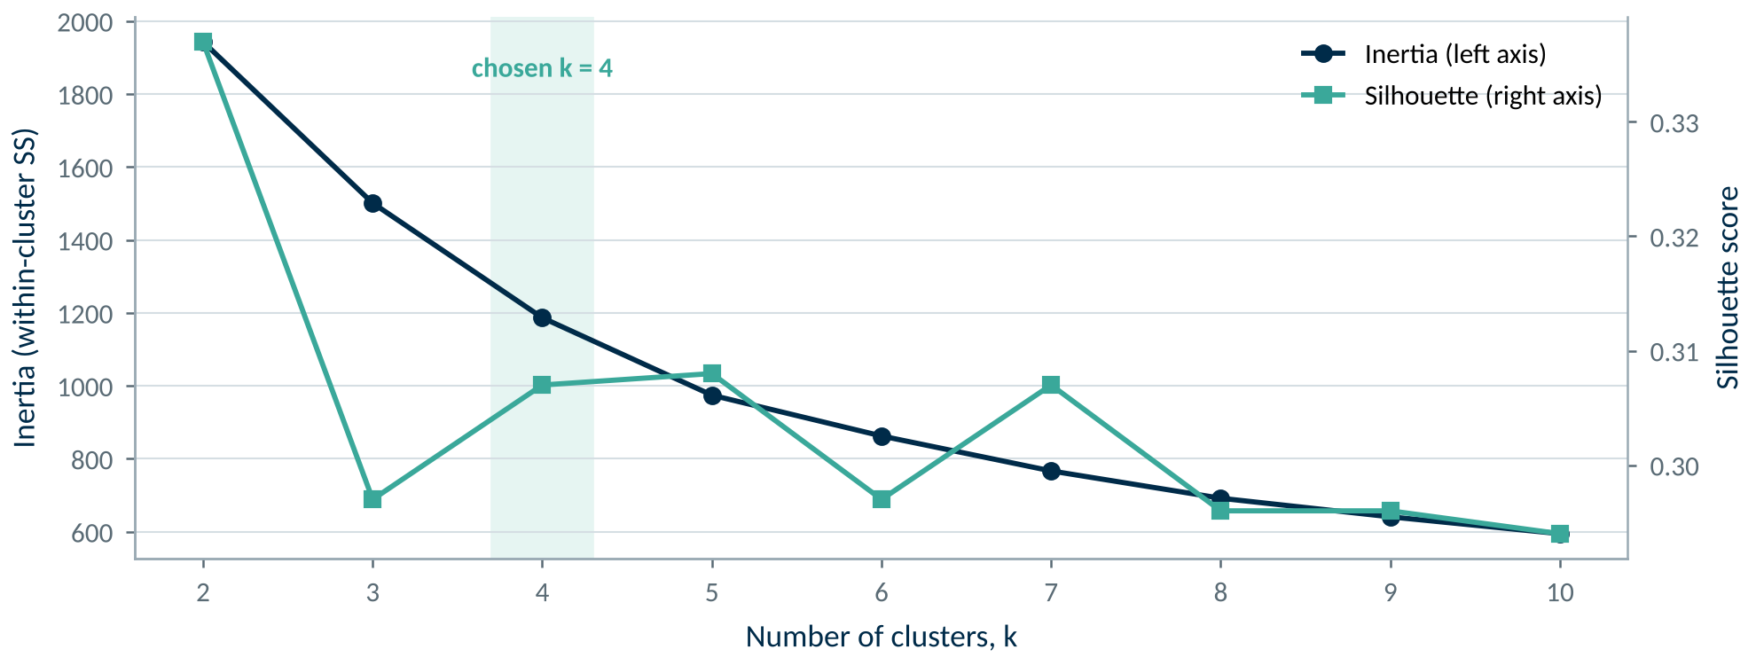
Figure 15. Elbow (inertia) and silhouette criteria across k.
Source: COM7022 - Assignment/output/figures/fig06_kmeans_elbow_silhouette.png
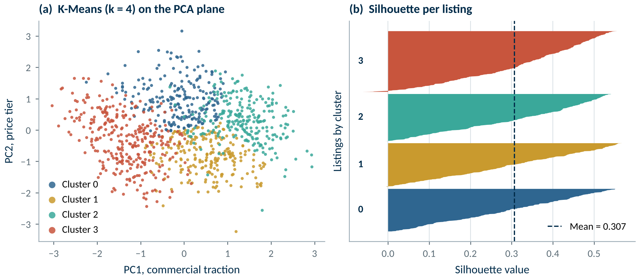
Figure 16. K-Means (k = 4) on the PCA plane and per-cluster silhouette profile.
Source: COM7022 - Assignment/output/figures/fig07_kmeans_clusters_silhouette.png

4.2 Hierarchical Clustering
Four linkage criteria were compared on identical Euclidean distances (Table 8). Single and average linkage suffer from chaining, absorbing 994 and 989 listings respectively into one cluster; complete linkage produces uneven groups (424/388/180/5). Ward linkage yields balanced, interpretable groups (358/237/235/167) and the highest silhouette among linkages (0.253). Its dendrogram separates into four branches at a merge height of roughly 21 (Figure 17), supporting a four-cluster cut that also enables a like-for-like comparison with K-Means. Agreement between the two partitions is moderate (ARI 0.41).
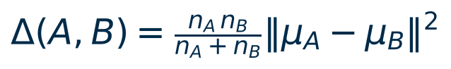

Table 8. Comparison of four hierarchical linkage criteria.
Linkage | Cophenetic correlation | Silhouette (k = 4) | Cluster sizes
single | 0.362 | 0.217 | 994/1/1/1
complete | 0.536 | 0.197 | 424/388/180/5
average | 0.631 | 0.206 | 989/6/1/1
ward | 0.579 | 0.253 | 358/237/235/167
Source: COM7022 - Assignment/output/tables/table08_linkage_comparison.csv
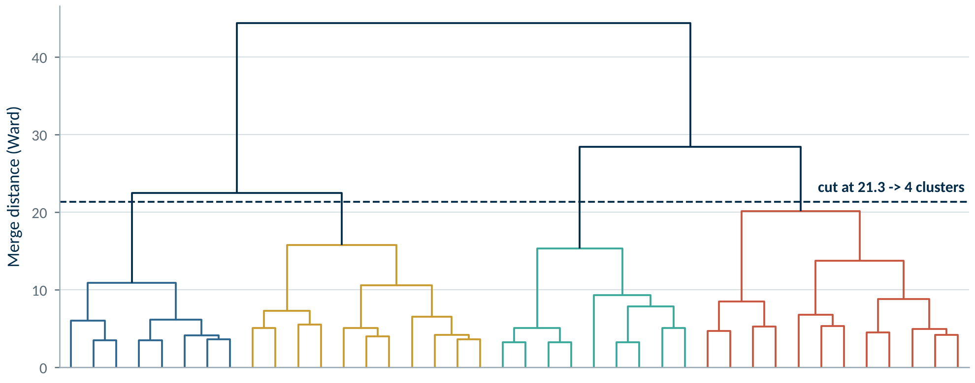
Figure 17. Ward dendrogram with the four-cluster cut.
Source: COM7022 - Assignment/output/figures/fig09_ward_dendrogram_cut.png

4.3 DBSCAN
MinPts was set to 6 (twice the dimensionality) and ε was read from the sorted 6-nearest-neighbour distance curve (Figure 18), followed by a 32-configuration grid search. The curve rises smoothly without a clear knee, a first sign that the catalogue lacks separated dense regions. Small radii (ε ≤ 0.35) reject 13–89% of listings as noise; larger radii merge almost everything. The best compromise (ε = 0.45) places 904 listings (90.7%) in one cluster, 4 in a second and 89 (8.9%) in noise, with a slightly negative silhouette (−0.014) (Figure 19).
This informative negative result shows that listings form a continuum rather than density islands. The noise set is distinctive (median price $26 vs $36, sales 163 vs 46, stock 5 vs 9), which makes DBSCAN useful as an anomaly detector.
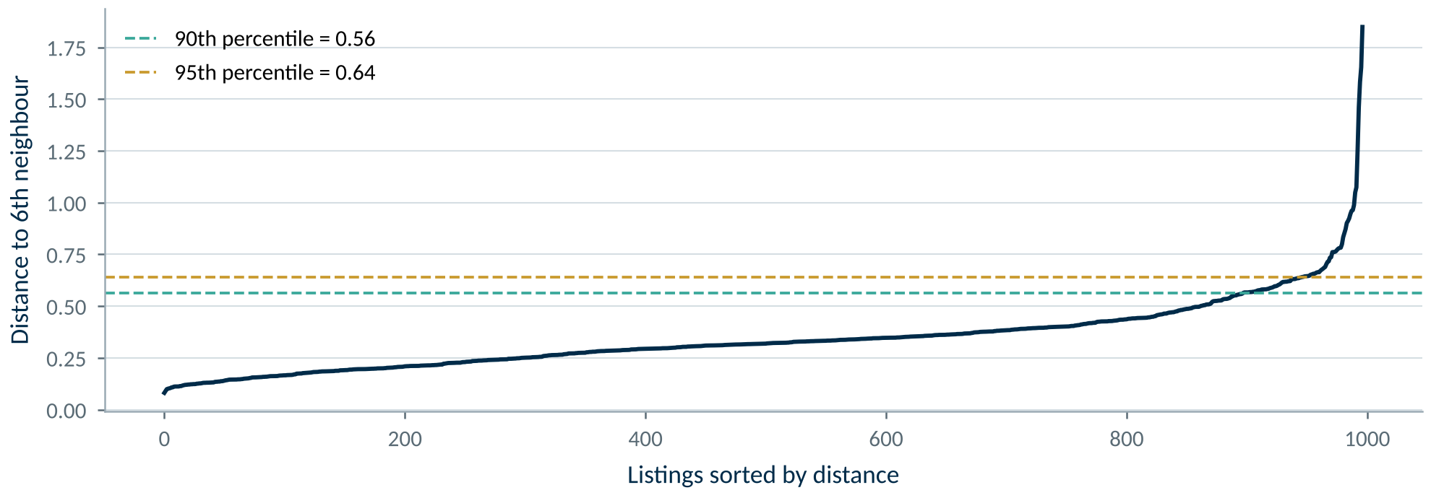
Figure 18. Sorted 6-nearest-neighbour distances used to select ε.
Source: COM7022 - Assignment/output/figures/fig10_dbscan_k_distance.png
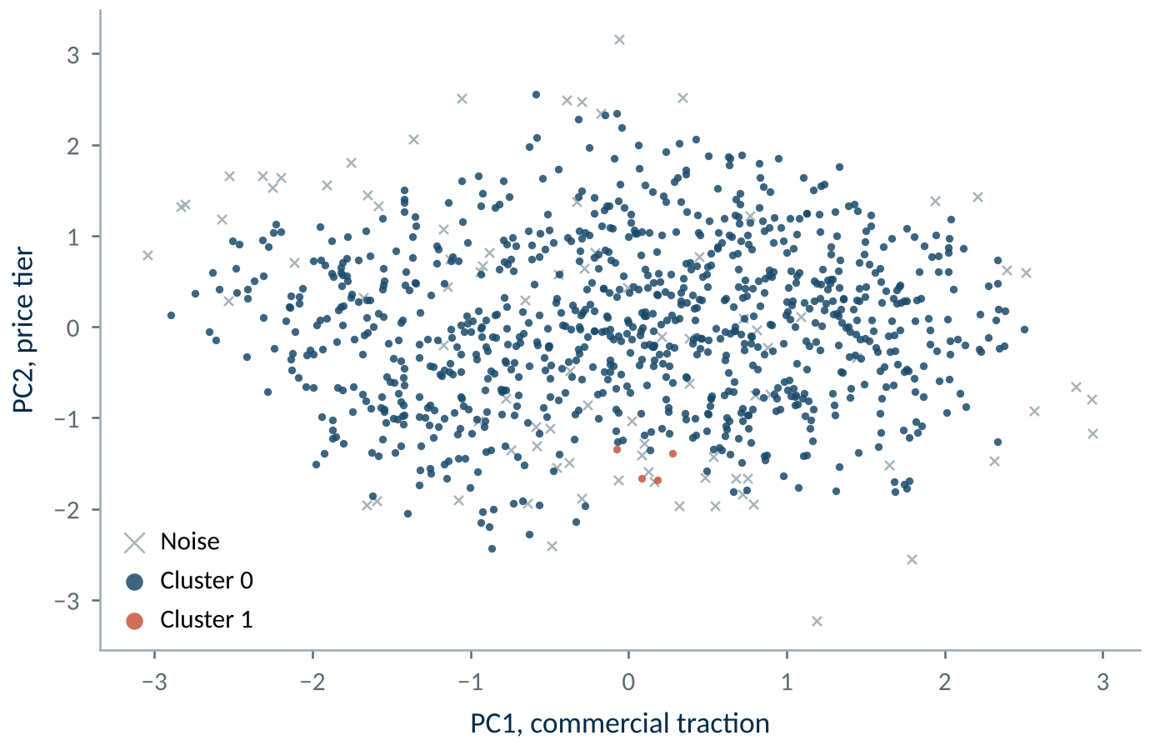
Figure 19. DBSCAN partition on the PCA plane; grey points are noise.
Source: COM7022 - Assignment/output/figures/fig11_dbscan_clusters.png

4.4 HDBSCAN
HDBSCAN directly tests whether DBSCAN failed merely because no single ε suits every region. With MinPts = 6 for comparability, a 15-configuration grid gave the same answer for every minimum cluster size from 20 to 100: two clusters with 47.0% of listings left as noise (Table 9, Figure 20). The larger cluster is the censoring artefact identified in Section 2.1: 89.1% of its members sit at the stock ceiling, against 41.5% of all listings. The smaller is a low-stock group (median 3 units). Jittering the integer stock scale or removing stock still leaves roughly 40–50% of listings outside any dense region. The more flexible algorithm therefore confirms the continuum and exposes a data-quality effect, but does not yield a commercial segmentation.
Table 9. HDBSCAN groups (min_cluster_size = 30, min_samples = 6) and their share of listings at the censored stock ceiling.
HDBSCAN group | Listings | Median price (US$) | Median units sold | Median stock | At stock ceiling (%)
Noise | 469 | 38.95 | 51 | 7 | 13.6
Cluster 0 | 393 | 29.99 | 116 | 11 | 89.1
Cluster 1 | 135 | 39.99 | 18 | 3 | 0
Source: COM7022 - Assignment/output/tables/table16_hdbscan_profile.csv
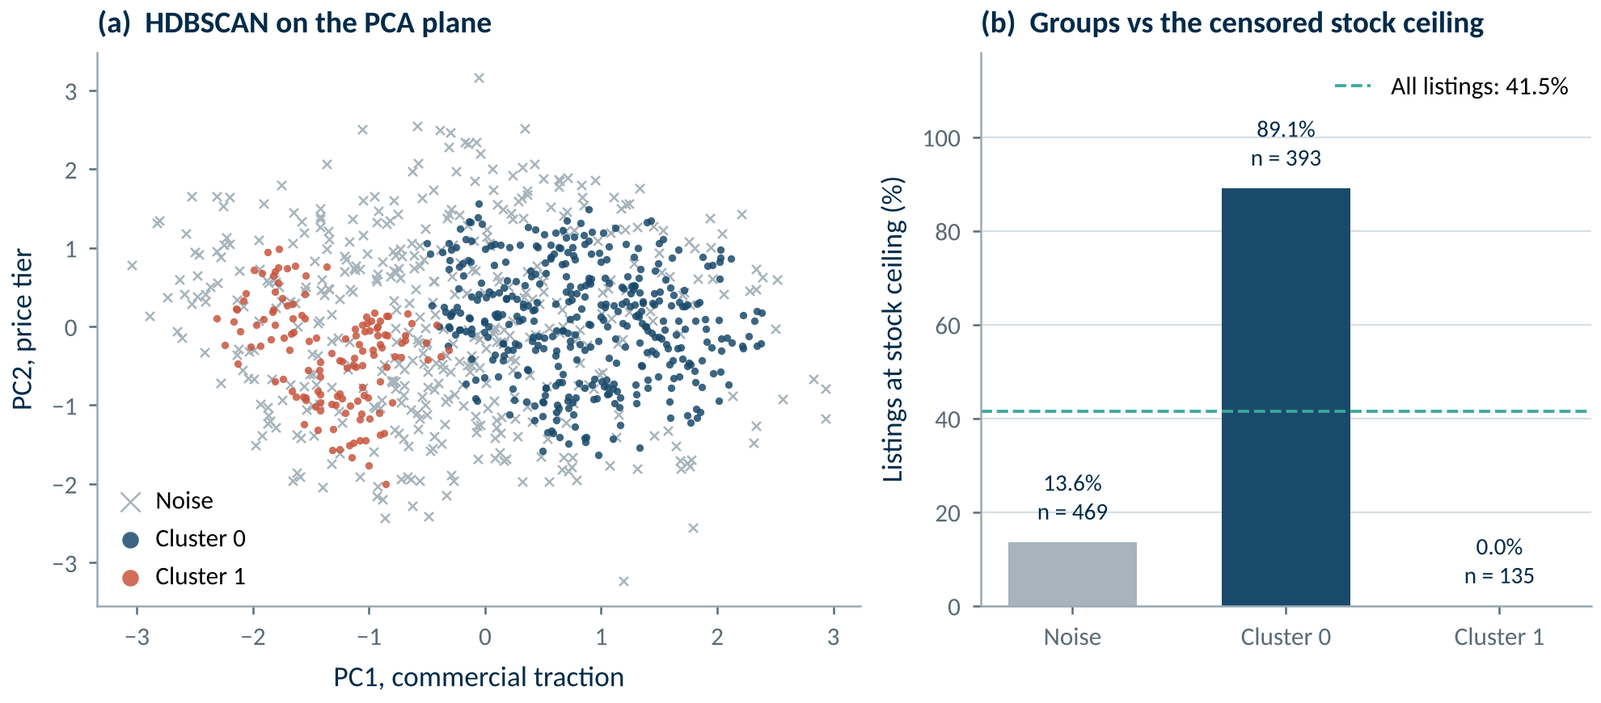
Figure 20. HDBSCAN on the PCA plane (a) and its alignment with the censored stock ceiling (b).
Source: COM7022 - Assignment/output/figures/fig18_hdbscan.png

4.5 TabClustPFN
TabClustPFN was run with the authors' pretrained checkpoint on the same standardised features, once choosing k itself and once with k fixed at 4 (Table 10, Figure 21). Inference took about three seconds on a local CPU and 44 seconds on a Colab CPU runtime. Left to decide, it predicts two clusters, consistently: the same k on all 30 subsamples, identical labels when the rows are shuffled, and the highest stability of any model (ARI 0.966). Its split is thin-stock listings against the rest, and 310 of the 312 listings in the K-Means low-stock segment fall in its smaller cluster. A model that never saw this data therefore confirms independently that stock position is the strongest structure in the catalogue.
Forced to four clusters it trails K-Means on every index (silhouette 0.152 against 0.307; Davies-Bouldin 1.71 against 1.02), and one group is 97% listings at the censored stock ceiling, the artefact HDBSCAN also found. The foundation model is valuable as an unbiased check on structure and on k, but it does not replace a well-prepared K-Means for a four-way business segmentation.
Table 10. TabClustPFN clusters with automatic k and with k fixed at 4.
Variant | Cluster | Listings | Median price (US$) | Median units sold | Units sold (%) | Median stock | At stock ceiling (%)
auto k = 2 | 0 | 410 | 39 | 19.5 | 6.9 | 3 | 0
auto k = 2 | 1 | 587 | 32.98 | 150 | 93.1 | 11 | 70.5
k = 4 | 0 | 150 | 51.99 | 21 | 0.6 | 8 | 10.7
k = 4 | 1 | 407 | 28.93 | 129 | 38.9 | 11 | 97.3
k = 4 | 2 | 299 | 37.99 | 16 | 3.2 | 3 | 0
k = 4 | 3 | 141 | 41 | 539 | 57.4 | 9 | 1.4
Source: COM7022 - Assignment/output/tables/table17_tabclustpfn.csv
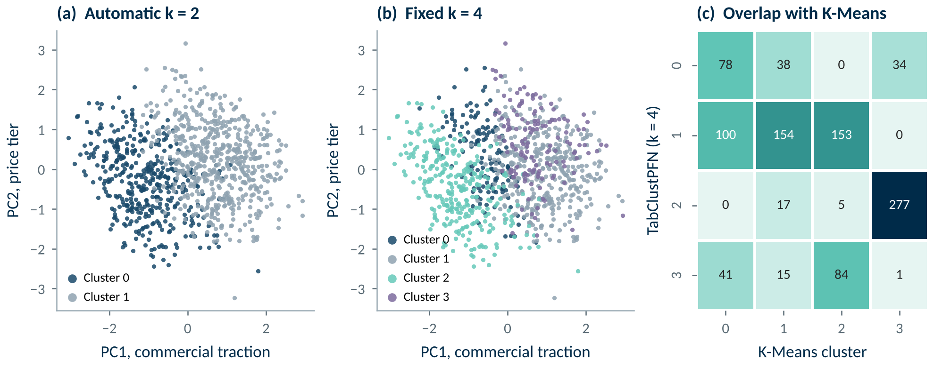
Figure 21. TabClustPFN with automatic k (a) and k = 4 (b), and the overlap of the k = 4 solution with K-Means (c).
Source: COM7022 - Assignment/output/figures/fig19_tabclustpfn.png

4.6 Evaluation Framework
Accuracy-type metrics require ground-truth labels and are therefore inapplicable to clustering. Model quality was instead triangulated across complementary measures, each answering a different question (Table 11). The silhouette coefficient (Rousseeuw, 1987) is defined for each listing as:
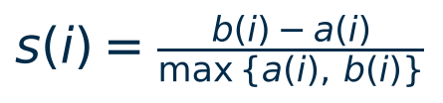

where a(i) is the mean distance to the listing's own cluster and b(i) to the nearest other one. Davies-Bouldin (Davies and Bouldin, 1979) and Calinski-Harabasz (Caliński and Harabasz, 1974) capture compactness against separation; the Adjusted Rand Index (Hubert and Arabie, 1985) measures agreement between partitions for the stability tests.
Table 11. Evaluation framework: complementary measures and what each can and cannot tell us.
Measure | What it captures | Better | Caveat
Silhouette | Cohesion vs separation of each listing (−1 to 1) | Higher | Favours convex clusters; ignores stability
Davies-Bouldin | Similarity of each cluster to its closest rival | Lower | Assumes centroid-shaped clusters
Calinski-Harabasz | Between- to within-cluster dispersion ratio | Higher | Inflated for convex clusters; weak for DBSCAN
Bootstrap stability (ARI) | Agreement of labels over 30 resamples of 80% | Higher (max 1) | Measures reproducibility, not quality
Sensitivity (ARI) | Agreement after changing seed, scaling or outliers | Higher (max 1) | Tests robustness to analyst choices
Coverage and balance | Share of noise; smallest and largest cluster | Low noise, balanced | Business usability rather than geometry

4.7 Comparative Results
Table 12. Comparative performance of the final models (density models scored on clustered listings only; TCP = TabClustPFN).
Model | Clusters | Noise % | Silhouette ↑ | DBI ↓ | CH ↑ | Stability ARI ↑ | Smallest % | Largest %
K-Means | 4 | 0 | 0.307 | 1.015 | 503.3 | 0.932 ± 0.025 | 22 | 31.3
Ward | 4 | 0 | 0.253 | 1.257 | 402.9 | 0.481 ± 0.084 | 16.8 | 35.9
DBSCAN | 2 | 8.9 | -0.014 | 1.172 | 3.5 | 0.749 ± 0.063 | 0.4 | 90.7
HDBSCAN | 2 | 47 | 0.48 | 0.785 | 476 | 0.705 ± 0.147 | 13.5 | 39.4
TCP (auto k) | 2 | 0 | 0.326 | 1.261 | 497.6 | 0.966 ± 0.024 | 41.1 | 58.9
TCP (k = 4) | 4 | 0 | 0.152 | 1.71 | 278.7 | 0.933 ± 0.036 | 14.1 | 40.8
Source: COM7022 - Assignment/output/tables/table11_model_comparison.csv
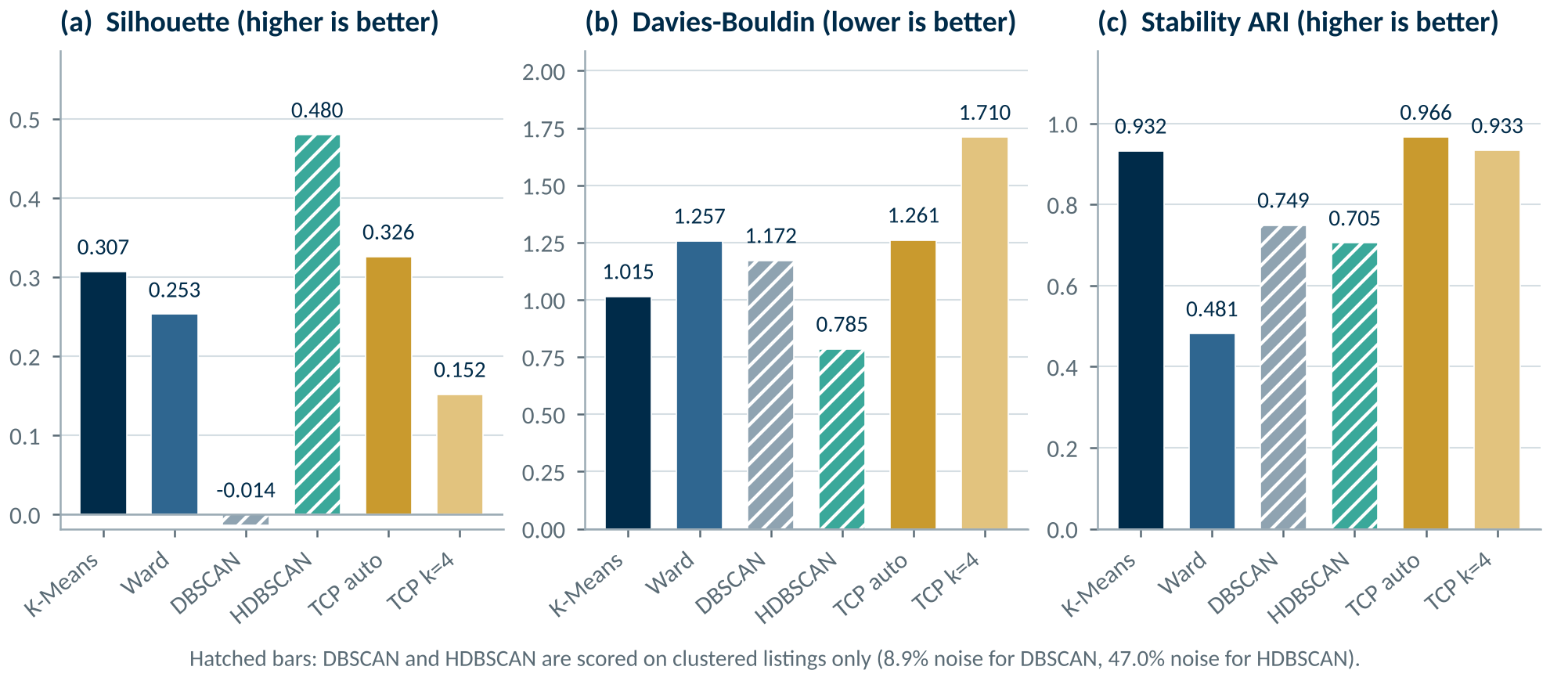
Figure 22. Internal validity and stability by model; hatched bars are scored on clustered listings only.
Source: COM7022 - Assignment/output/figures/fig12_model_comparison.png
Among models that assign every listing, K-Means leads on every internal index: silhouette 0.307 versus 0.253 for Ward, Davies-Bouldin 1.015 versus 1.257, Calinski-Harabasz 503.3 versus 402.9. TabClustPFN's automatic two-cluster solution scores a similar silhouette (0.326) to K-Means at the same k (0.337), but at k = 4 it is clearly weaker. HDBSCAN's higher silhouette (0.480) is not comparable, because it is computed on the 53% of listings it retains; scoring only the easiest points inflates every index. Stability is decisive: across 30 resamples of 80% of the data, K-Means reproduces its partition almost exactly (ARI 0.932 ± 0.025), whereas Ward does not (0.481 ± 0.084) because early merges in a hierarchy are irreversible and small sample changes propagate up the tree. TabClustPFN is equally stable (0.966 automatic, 0.933 at k = 4), so stability alone does not separate the two; segment quality at k = 4 does.
Sensitivity tests confirm robustness (Table 13): changing the seed (mean ARI 0.984) or removing the top 1% of sellers (0.937) barely alters the solution, so the log transform neutralised outlier leverage. Only min-max scaling (0.492) materially changes it, justifying standardisation.
Table 13. Robustness of the K-Means solution to analytical choices.
Sensitivity test (K-Means, k = 4) | ARI
K-Means across 10 seeds (mean ARI) | 0.984
z-score vs min-max scaling (ARI) | 0.492
with vs without top 1% sellers (ARI) | 0.937
Source: COM7022 - Assignment/output/tables/table12_sensitivity_checks.csv
Model Selection Decision: K-Means (k = 4) is selected as the production segmentation engine: best internal validity among full-coverage models, near-perfect stability and full catalogue coverage. Ward is retained as a structural cross-check, DBSCAN as an anomaly flag, HDBSCAN as a data-quality probe and TabClustPFN as an independent check on the number of segments.

5. Cluster Characteristics
Mapping centroids back to business units reveals four distinct commercial segments (Table 14, Figure 23, Figure 24):
- Cluster 2 — Best-Sellers (24.3% of listings). The revenue engine: 92.3% of all units sold (710,124 of 769,317) at an accessible median $29.94, with full stock. Mostly Eau de Toilette from lines such as Armaf and Ralph Lauren.
- Cluster 0 — Premium Designer (22.0%). The highest prices (median $68.99) with steady but slow demand (3.7% of volume); Eau de Parfum from Giorgio Armani, Paco Rabanne and Yves Saint Laurent.
- Cluster 1 — Budget Commodities (22.5%). The cheapest offers (median $18.99) yet only 1.8% of volume, with the most unbranded items: low price alone does not create demand.
- Cluster 3 — Low-Stock Tail (31.3%). Median stock of 3 units, 14.1% at "Last One" and minimal sales (2.2% of volume): an imminent stock-out risk.
Table 14. Business profile of the four K-Means segments.
Measure | C2 Best-Sellers | C0 Premium | C1 Budget | C3 Low-Stock
Listings | 242 | 219 | 224 | 312
Share of listings (%) | 24.3 | 22 | 22.5 | 31.3
Median price (US$) | 29.94 | 68.99 | 18.99 | 39.99
Median units sold | 952 | 43 | 30 | 16
Share of units sold (%) | 92.3 | 3.7 | 1.8 | 2.2
Median stock level | 11 | 11 | 11 | 3
Listings at 'Last One' (%) | 1.2 | 0 | 0 | 14.1
Ships from US (%) | 99.6 | 84.9 | 92 | 88.5
Dominant product type | Eau de Toilette (67.8%) | Eau de Parfum (45.2%) | Eau de Toilette (37.9%) | Eau de Toilette (39.1%)
Source: COM7022 - Assignment/output/tables/table13_cluster_profiles.csv
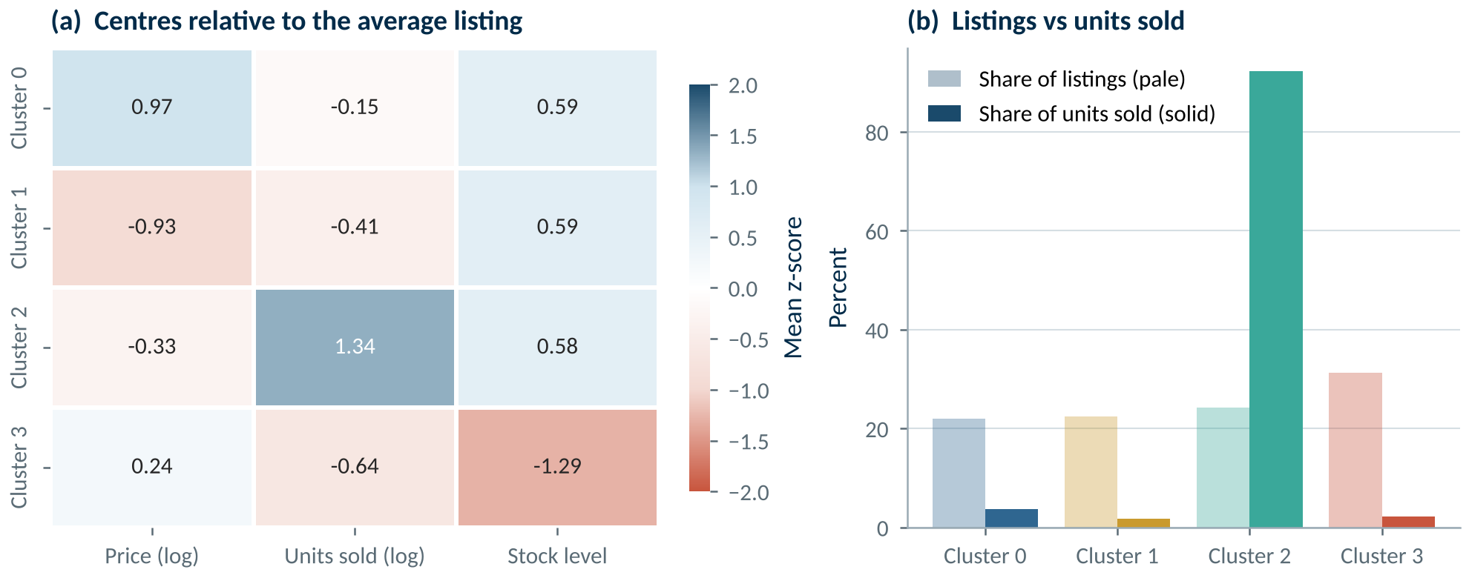
Figure 23. Standardised feature means per cluster.
Source: COM7022 - Assignment/output/figures/fig13_cluster_profiles.png
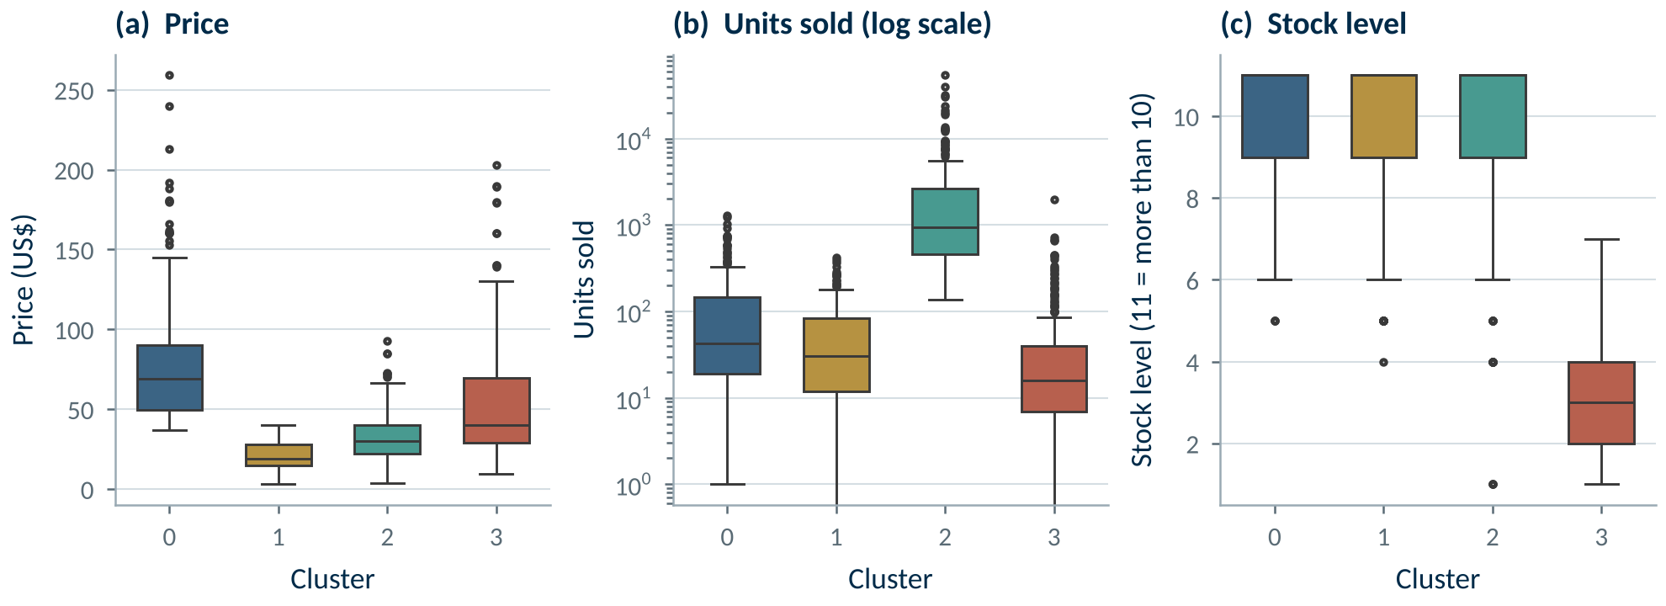
Figure 24. Price, sales and stock distributions within each cluster.
Source: COM7022 - Assignment/output/figures/fig14_cluster_distributions.png

TASK 2
Critical Report for Executive Stakeholders
947 words of body text

6. Executive Summary
Machine learning reveals that our 997 fragrance listings fall into four natural commercial segments. One quarter of listings — the best-sellers — generate 92% of all units sold, while almost a third of the catalogue is close to running out of stock. The recommended model, K-Means with four segments, produced better segments than four alternatives, including a 2026 AI foundation model, is among the most stable, and is simple enough to run automatically on new listings. Each segment calls for a distinct action: protect, grow, reposition or audit.
CORE REVENUE ENGINE  92.3%  of units sold come from 24.3% of listings (Cluster 2) | INVENTORY RISK  31.3%  of listings sit in the low-stock tail (Cluster 3) | MODEL STABILITY  0.932  K-Means bootstrap ARI over 30 resamples | PCA VARIANCE  78.7%  retained by the first two components

7. Critical Evaluation

7.1 Suitability of the Methods and Design Decisions
Unsupervised clustering is the right tool because the company holds no labelled outcomes; the aim is discovery rather than prediction. Three design decisions shaped the outcome. The log transformation stopped a handful of viral listings from dictating the segmentation. The choice of price, sales and stock answers the three questions managers actually ask — what is it worth, does it sell, will it run out? Excluding brand and country from the distance calculation prevented segments from degenerating into brand lists. Each decision was tested rather than assumed: the result survives changes of seed and the removal of top sellers.

7.2 Comparative Performance: Strengths and Limitations
K-Means was the strongest model on every measure. Its limitation is that it assumes compact, similarly sized groups and requires the number of segments to be chosen; on a continuous catalogue its boundaries are therefore soft, as the moderate silhouette (0.31) honestly reflects. Ward hierarchical clustering offers an intuitive tree of nested groups but proved unstable: its segments changed substantially whenever the sample changed, and it cannot assign new listings without rebuilding the tree. DBSCAN excels at irregular shapes and outlier detection, but placed 91% of listings in one group. HDBSCAN, the newest technique tested, removes DBSCAN's fragile radius setting, yet still left almost half the catalogue unassigned, and its densest cluster reflected how the platform records stock rather than how listings sell. TabClustPFN, a pre-trained foundation model, needs no tuning and is very stable, and its automatic choice of two clusters is a useful sanity check; but it is a black box that depends on externally hosted weights, and when asked for four segments it produced weaker, less commercially meaningful groups than K-Means. Newer is therefore not automatically better: on a small, well-understood table, careful preparation and a transparent model win. These weaknesses are properties of the data as much as of the algorithms, which is itself a valuable insight into how the marketplace is structured.

7.3 Why K-Means Is the Right Choice for E-Commerce
Technical scores are only half the decision. An e-commerce platform needs a model that covers every listing, can be refreshed frequently, scores new listings instantly, scales to millions of offers and can be explained to managers (Table 15). K-Means satisfies all five requirements: each new listing is assigned to its nearest centroid in microseconds, and each centroid reads as a typical price, sales level and stock position. A simple sales ranking would not suffice: it shows who sells most, but not who is premium, cheap yet stagnant, or about to run out.
Table 15. Operational suitability of each model for an e-commerce platform.
Requirement | K-Means | Ward | DBSCAN | HDBSCAN | TabClustPFN
Covers every listing | Yes · 0% noise | Yes · 0% noise | No · 8.9% noise | No · 47.0% noise | Yes · 0% noise
Scores new listings instantly | Yes · nearest centroid | No · rebuild tree | Partly | Partly | Partly · re-run (~3 s)
Stable between refreshes | Yes · ARI 0.93 | No · ARI 0.48 | Partly · 0.75 | Partly · 0.71 | Yes · ARI 0.93–0.97
Scales to millions of listings | Yes · linear | No · quadratic | Partly | Partly | No · context limit
Explainable to managers | Yes · four profiles | Partly | No · one group | No · half noise | Partly · black box
Recommended role | Production model | Cross-check | Anomaly flag | Data-quality probe | Check on k

8. Recommendations for Business Managers
The four segments translate into targeted, measurable interventions (Figure 25):
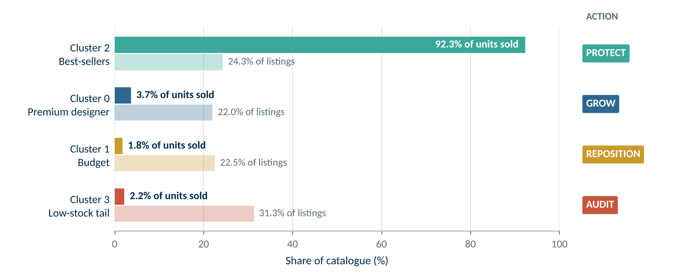
Figure 25. Share of listings versus share of units sold per segment, with the recommended action.
Source: COM7022 - Assignment/output/figures/fig17_segment_actions.png
PROTECT · CLUSTER 2  Secure the revenue engine  Evidence: 92.3% of units sold from 24.3% of listings.  Action: Automated restock alerts below 10 units, priority search placement and fulfilment SLAs for these sellers. | GROW · CLUSTER 0  Monetise the premium tier  Evidence: Highest prices (median $68.99) with steady, slow demand.  Action: Bundle with best-sellers on product pages and invest in premium content rather than discounting.
REPOSITION · CLUSTER 1  Stop subsidising weak demand  Evidence: Cheapest offers (median $18.99) yet only 1.8% of volume.  Action: End paid promotion of unbranded items and reallocate budget to proven brands. | AUDIT · CLUSTER 3  Clean up the low-stock tail  Evidence: 31.3% of listings, median stock of 3, 14.1% at 'Last One'.  Action: 30-day merchant restock notices; delist listings that remain empty and unsold after 60 days.

Implementation should begin with the best-sellers and the low-stock tail, which protect the most revenue for the least effort. Success should be tracked through stock-outs in Cluster 2, the proportion of Cluster 3 listings restocked or delisted within 30 days, and sales per advertising dollar in Cluster 1. The segmentation should be refreshed monthly, with new listings scored on arrival and DBSCAN noise points reviewed as potential anomalies.

9. Limitations
The platform caps visible stock at ten units, so genuine depth above that level is unknown. The data is a single snapshot of one product family, so segment boundaries may differ in other categories or seasons. Clusters describe association, not causation: a premium price does not itself make a listing slow. Finally, because listings form a continuum, those near a boundary could reasonably belong to either neighbouring segment; the segments should guide prioritisation rather than replace commercial judgement.

10. Conclusion and Future Work
This project demonstrates that a carefully prepared, well-validated K-Means model can turn an unlabelled and messy catalogue into four clear, actionable segments, and that the commercial value of the catalogue is extraordinarily concentrated. The most important lesson is that data preparation mattered more than algorithm choice, even against a state-of-the-art foundation model: recovering values from listing text and correcting the hidden stock ceiling changed the outcome more than any hyperparameter. Equally, the density methods were not wasted effort: DBSCAN and HDBSCAN together provided the clearest evidence that the marketplace is a continuum, and HDBSCAN exposed how stock censoring distorts the data. TabClustPFN added an independent, pre-trained view that agreed on the dominant stock split.
Future work would enrich the feature space with revenue, margin and true stock counts (removing the censoring that misled two of the models), incorporate text embeddings of product descriptions, and track segment migration over time to detect listings that are rising or declining. Validating whether segment membership predicts next-quarter sales would convert the descriptive model into a forward-looking decision tool, and a lightweight dashboard would place each listing's segment directly in the hands of category managers.

References
Campello, R.J.G.B., Moulavi, D. and Sander, J. (2013) 'Density-based clustering based on hierarchical density estimates', in Advances in Knowledge Discovery and Data Mining (PAKDD 2013). Berlin: Springer, pp. 160–172.
Caliński, T. and Harabasz, J. (1974) 'A dendrite method for cluster analysis', Communications in Statistics, 3(1), pp. 1–27.
Davies, D.L. and Bouldin, D.W. (1979) 'A cluster separation measure', IEEE Transactions on Pattern Analysis and Machine Intelligence, PAMI-1(2), pp. 224–227.
Ester, M., Kriegel, H.-P., Sander, J. and Xu, X. (1996) 'A density-based algorithm for discovering clusters in large spatial databases with noise', in Proceedings of the Second International Conference on Knowledge Discovery and Data Mining. Portland: AAAI Press, pp. 226–231.
Hollmann, N., Müller, S., Purucker, L., Krishnakumar, A., Körfer, M., Hoo, S.B., Schirrmeister, R.T. and Hutter, F. (2025) 'Accurate predictions on small data with a tabular foundation model', Nature, 637, pp. 319–326.
Hubert, L. and Arabie, P. (1985) 'Comparing partitions', Journal of Classification, 2(1), pp. 193–218.
MacQueen, J. (1967) 'Some methods for classification and analysis of multivariate observations', in Proceedings of the Fifth Berkeley Symposium on Mathematical Statistics and Probability. Berkeley: University of California Press, pp. 281–297.
McInnes, L., Healy, J. and Astels, S. (2017) 'hdbscan: Hierarchical density based clustering', Journal of Open Source Software, 2(11), p. 205.
McKinney, W. (2010) 'Data structures for statistical computing in Python', in Proceedings of the 9th Python in Science Conference, pp. 56–61.
Müller, A.C. and Guido, S. (2016) Introduction to Machine Learning with Python. Sebastopol: O'Reilly Media.
Pearson, K. (1901) 'On lines and planes of closest fit to systems of points in space', Philosophical Magazine, 2(11), pp. 559–572.
Pedregosa, F. et al. (2011) 'Scikit-learn: machine learning in Python', Journal of Machine Learning Research, 12, pp. 2825–2830.
Rousseeuw, P.J. (1987) 'Silhouettes: a graphical aid to the interpretation and validation of cluster analysis', Journal of Computational and Applied Mathematics, 20, pp. 53–65.
Ward, J.H. (1963) 'Hierarchical grouping to optimize an objective function', Journal of the American Statistical Association, 58(301), pp. 236–244.
Zhao, T., Wang, G., Tan, Y.S. and Zhang, Q. (2026) 'TabClustPFN: a prior-fitted network for tabular data clustering', arXiv preprint arXiv:2601.21656.

Appendix A: Reproducible Code
The complete Task 1 implementation is a single Jupyter notebook that executes end to end in about 30 seconds on Google Colab or locally, with fixed random seeds (42). All materials — notebook, dataset, figures, tables and code screenshots — are hosted in the project repository: https://github.com/kvmmn/_COM7022_MachineLearning. TabClustPFN is run from the authors' public code and checkpoint (CC BY-NC 4.0 licence, used for non-commercial coursework); the notebook downloads both and, because R's rpy2 is only needed to generate the model's pre-training data, supplies a placeholder module that raises an error if ever called. The notebook was executed on Google Colab (scikit-learn 1.6.1, no GPU needed) as well as locally (1.9.1), and every reported figure reproduced; the only difference is in the third decimal of one standard deviation (HDBSCAN stability, 0.149 on Colab against 0.147 locally). The full notebook code follows, one screenshot per cell in execution order.

A · 0. Set-up
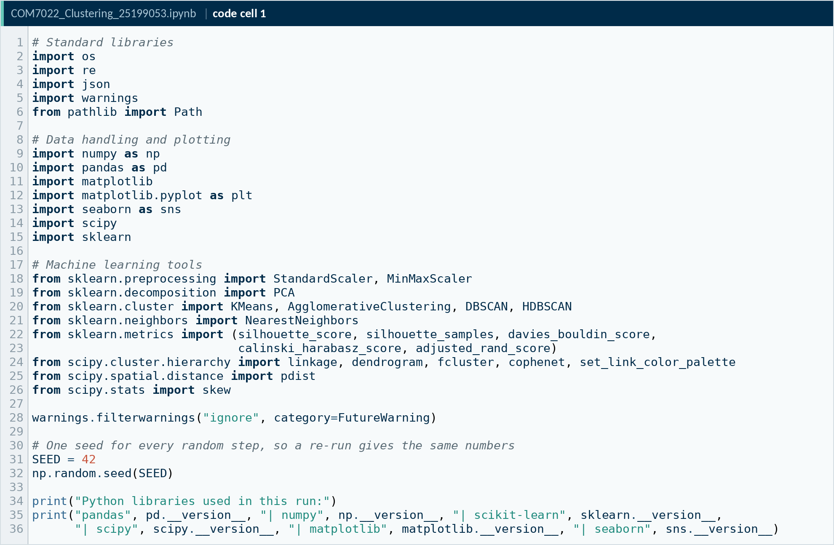
Code A1. Notebook code cell 1
Source: COM7022 - Assignment/output/screenshots/appendix/cell01.png
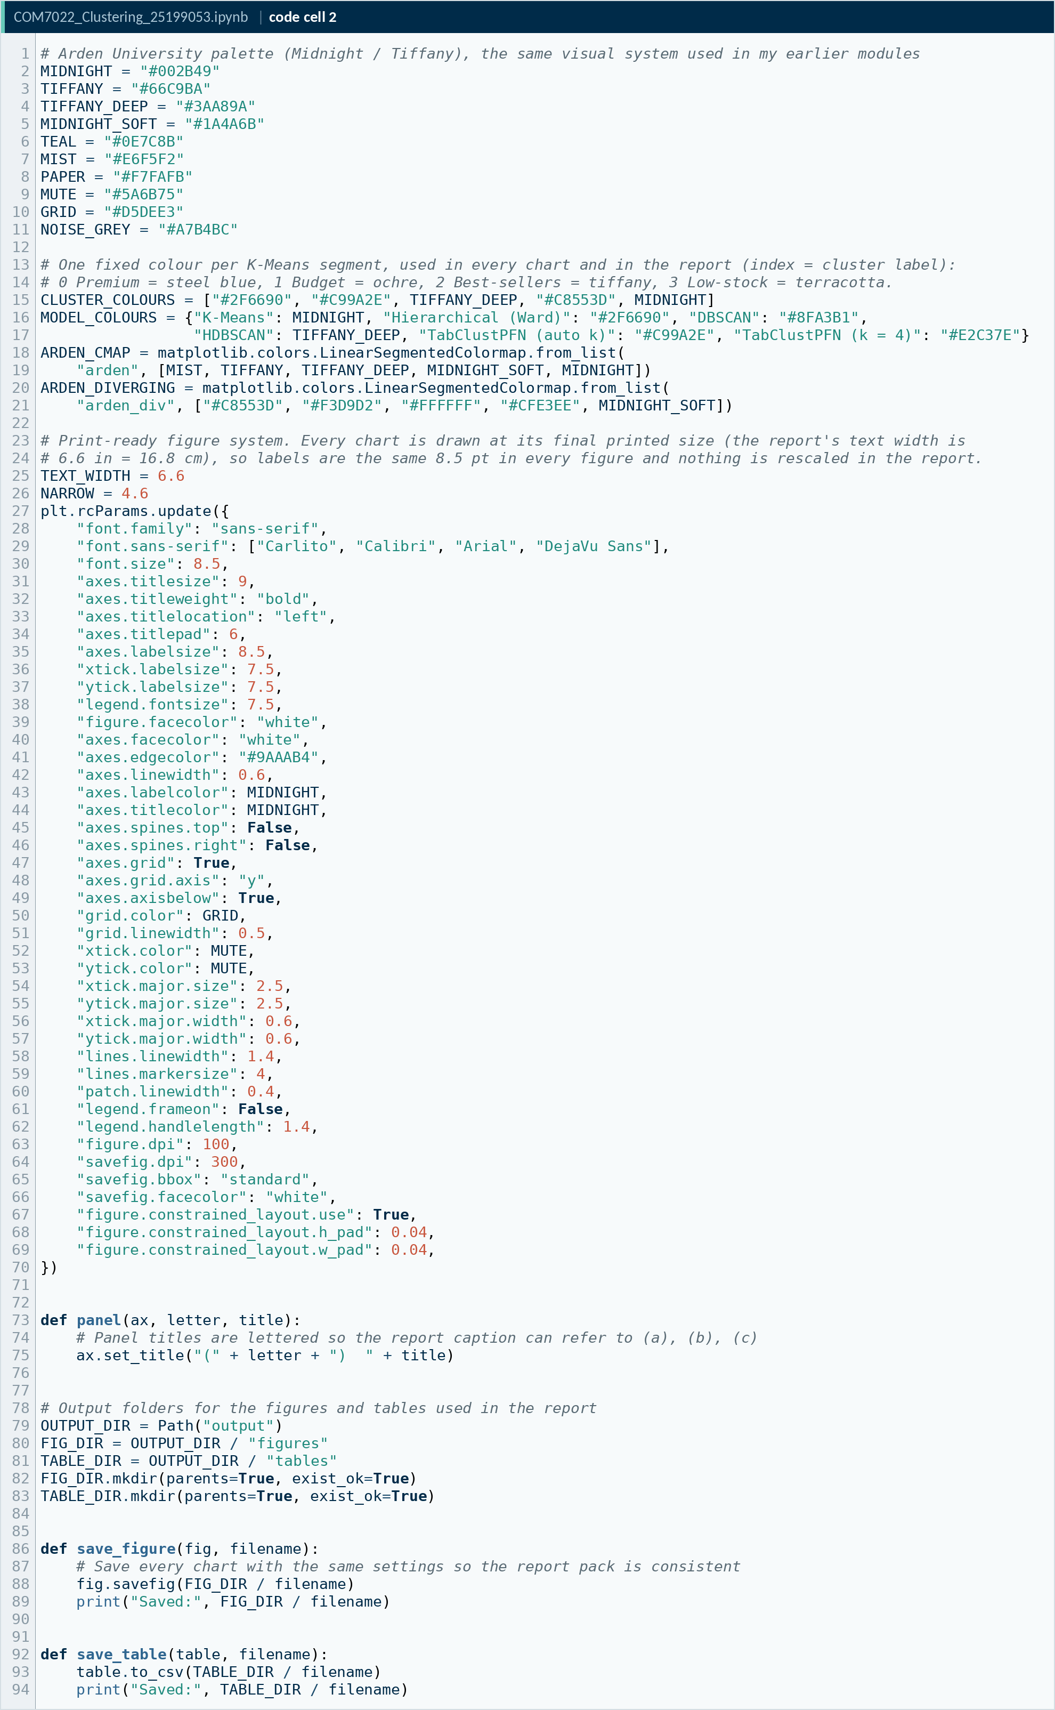
Code A2. Notebook code cell 2
Source: COM7022 - Assignment/output/screenshots/appendix/cell02.png

A · 1. Data import
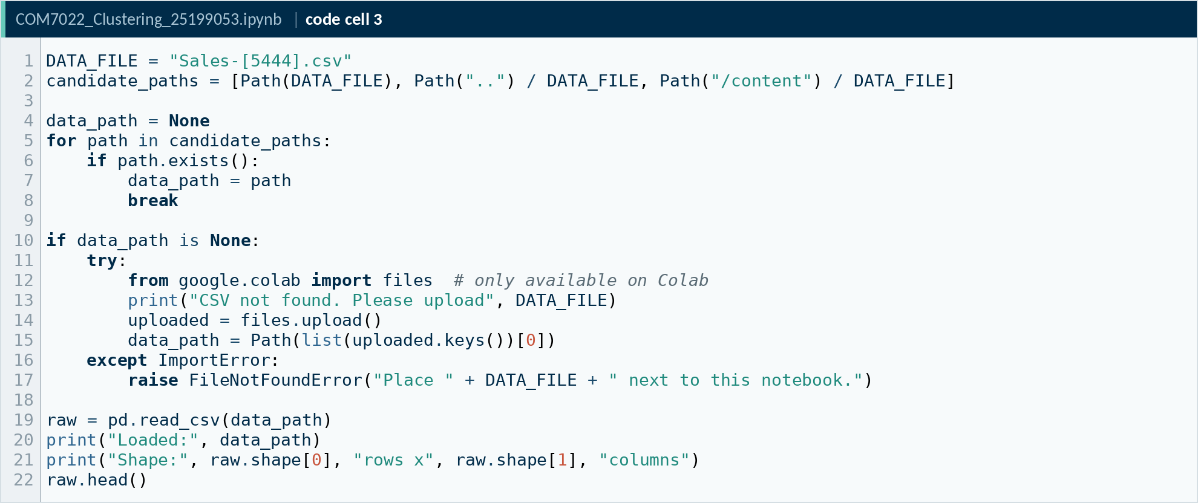
Code A3. Notebook code cell 3
Source: COM7022 - Assignment/output/screenshots/appendix/cell03.png
Code A4. Notebook code cell 4
Source: COM7022 - Assignment/output/screenshots/appendix/cell04.png

A · 2. Descriptive statistics and data quality
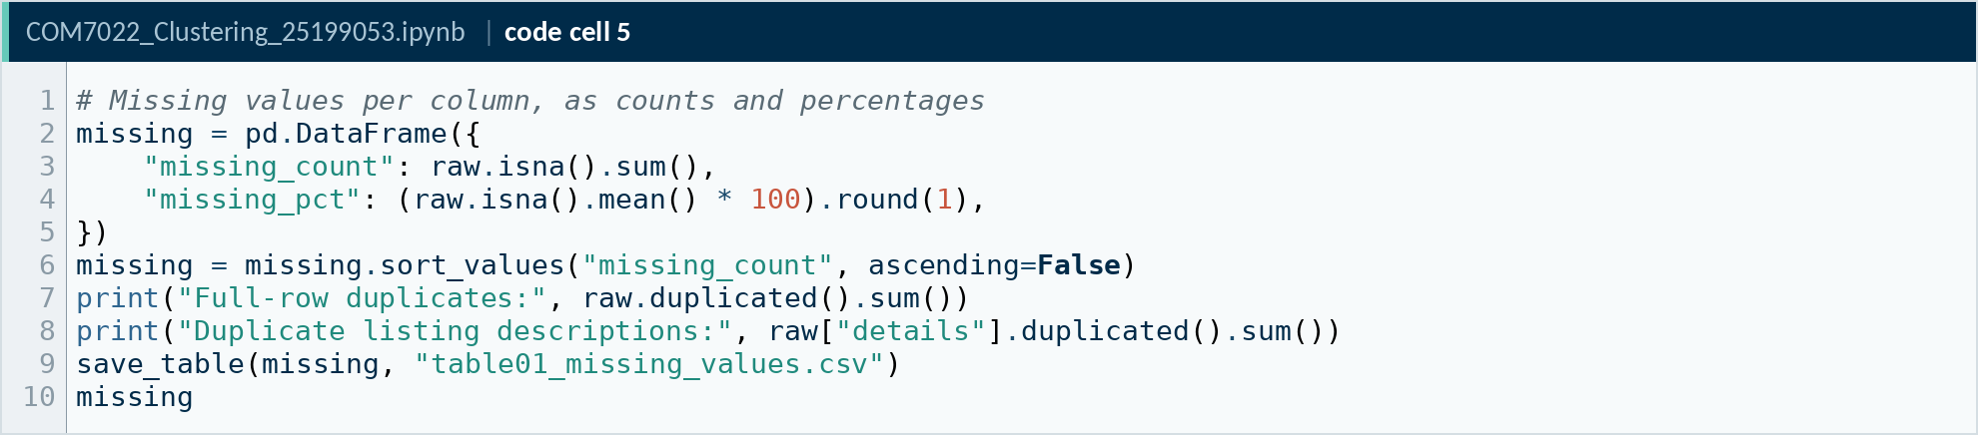
Code A5. Notebook code cell 5
Source: COM7022 - Assignment/output/screenshots/appendix/cell05.png
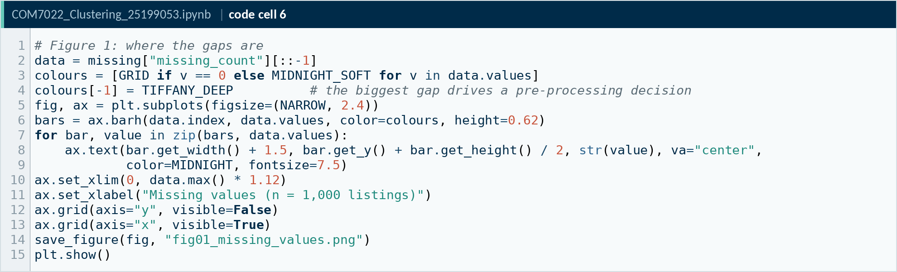
Code A6. Notebook code cell 6
Source: COM7022 - Assignment/output/screenshots/appendix/cell06.png
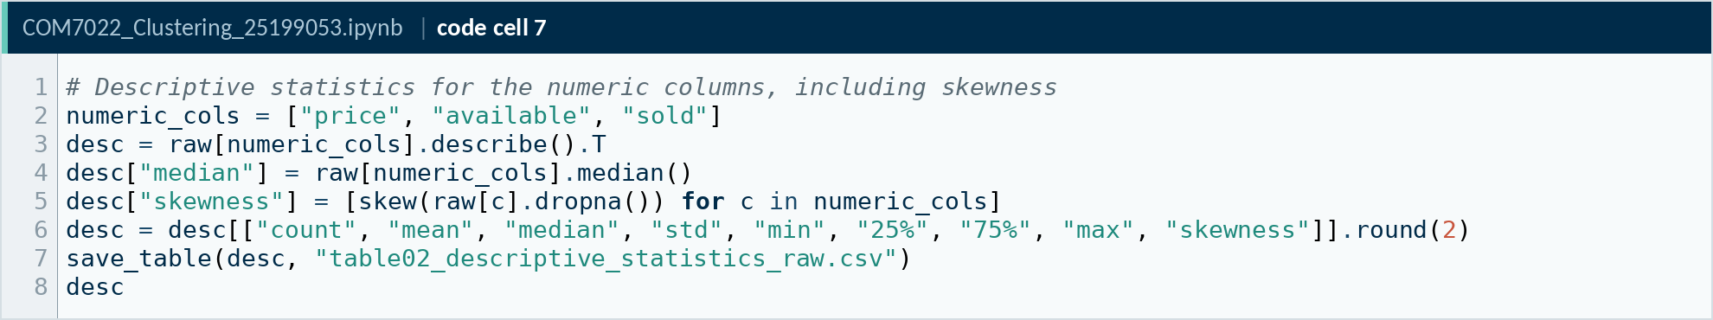
Code A7. Notebook code cell 7
Source: COM7022 - Assignment/output/screenshots/appendix/cell07.png
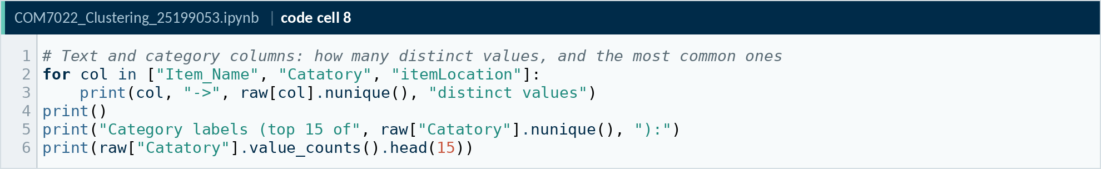
Code A8. Notebook code cell 8
Source: COM7022 - Assignment/output/screenshots/appendix/cell08.png
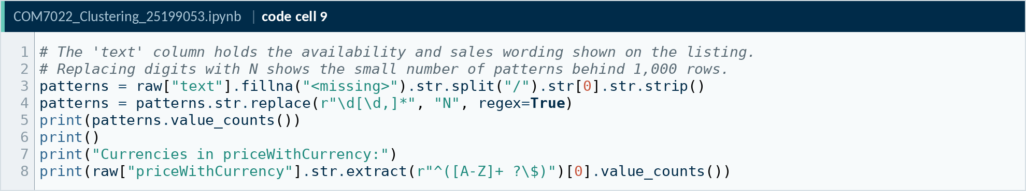
Code A9. Notebook code cell 9
Source: COM7022 - Assignment/output/screenshots/appendix/cell09.png
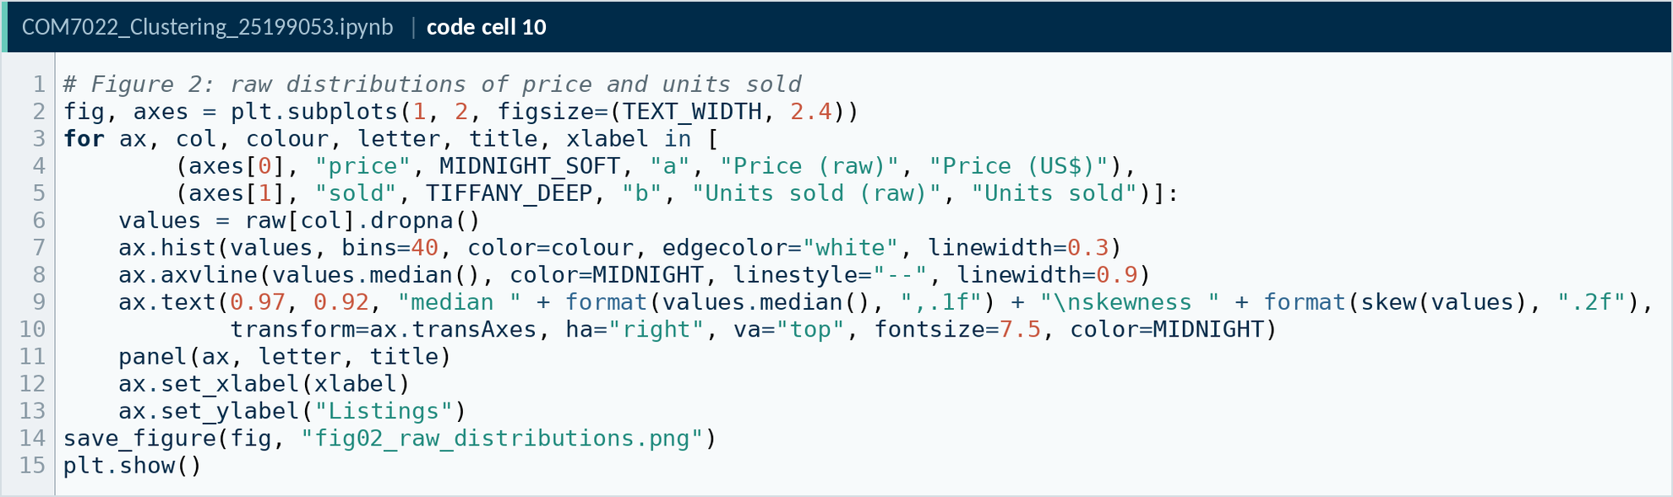
Code A10. Notebook code cell 10
Source: COM7022 - Assignment/output/screenshots/appendix/cell10.png

A · 3. Pre-processing
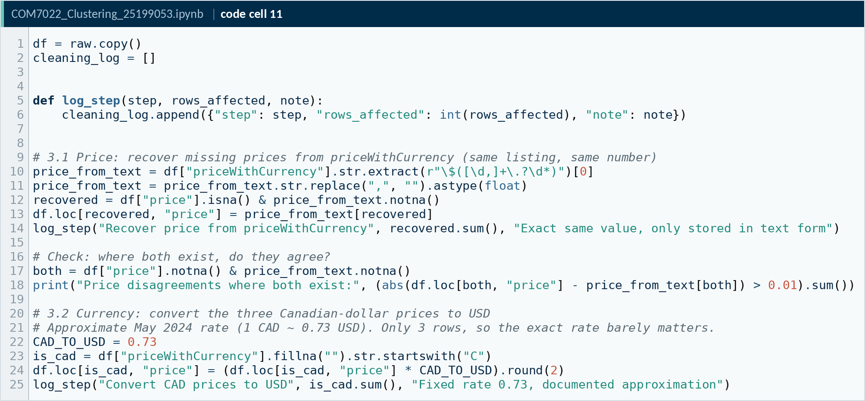
Code A11. Notebook code cell 11
Source: COM7022 - Assignment/output/screenshots/appendix/cell11.png
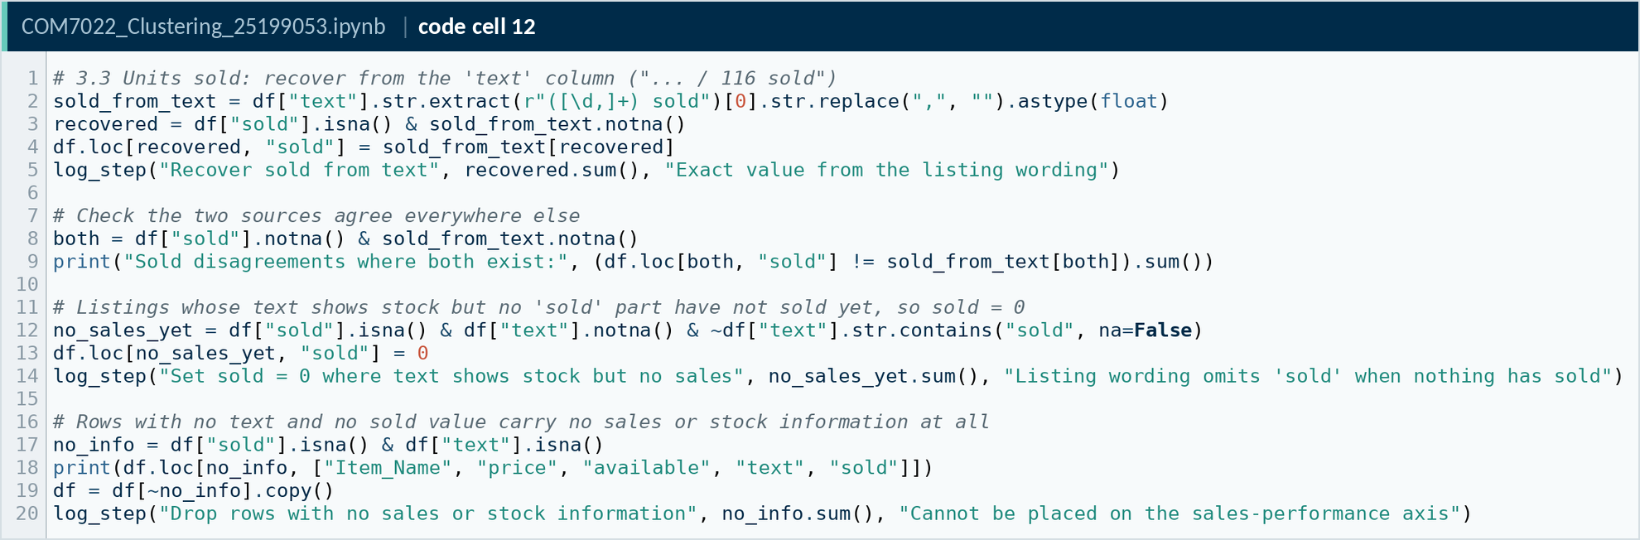
Code A12. Notebook code cell 12
Source: COM7022 - Assignment/output/screenshots/appendix/cell12.png
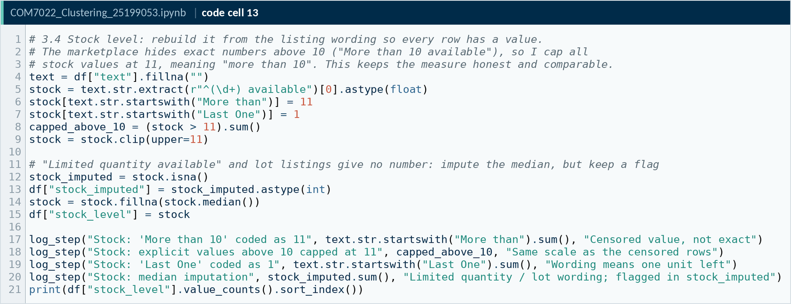
Code A13. Notebook code cell 13
Source: COM7022 - Assignment/output/screenshots/appendix/cell13.png
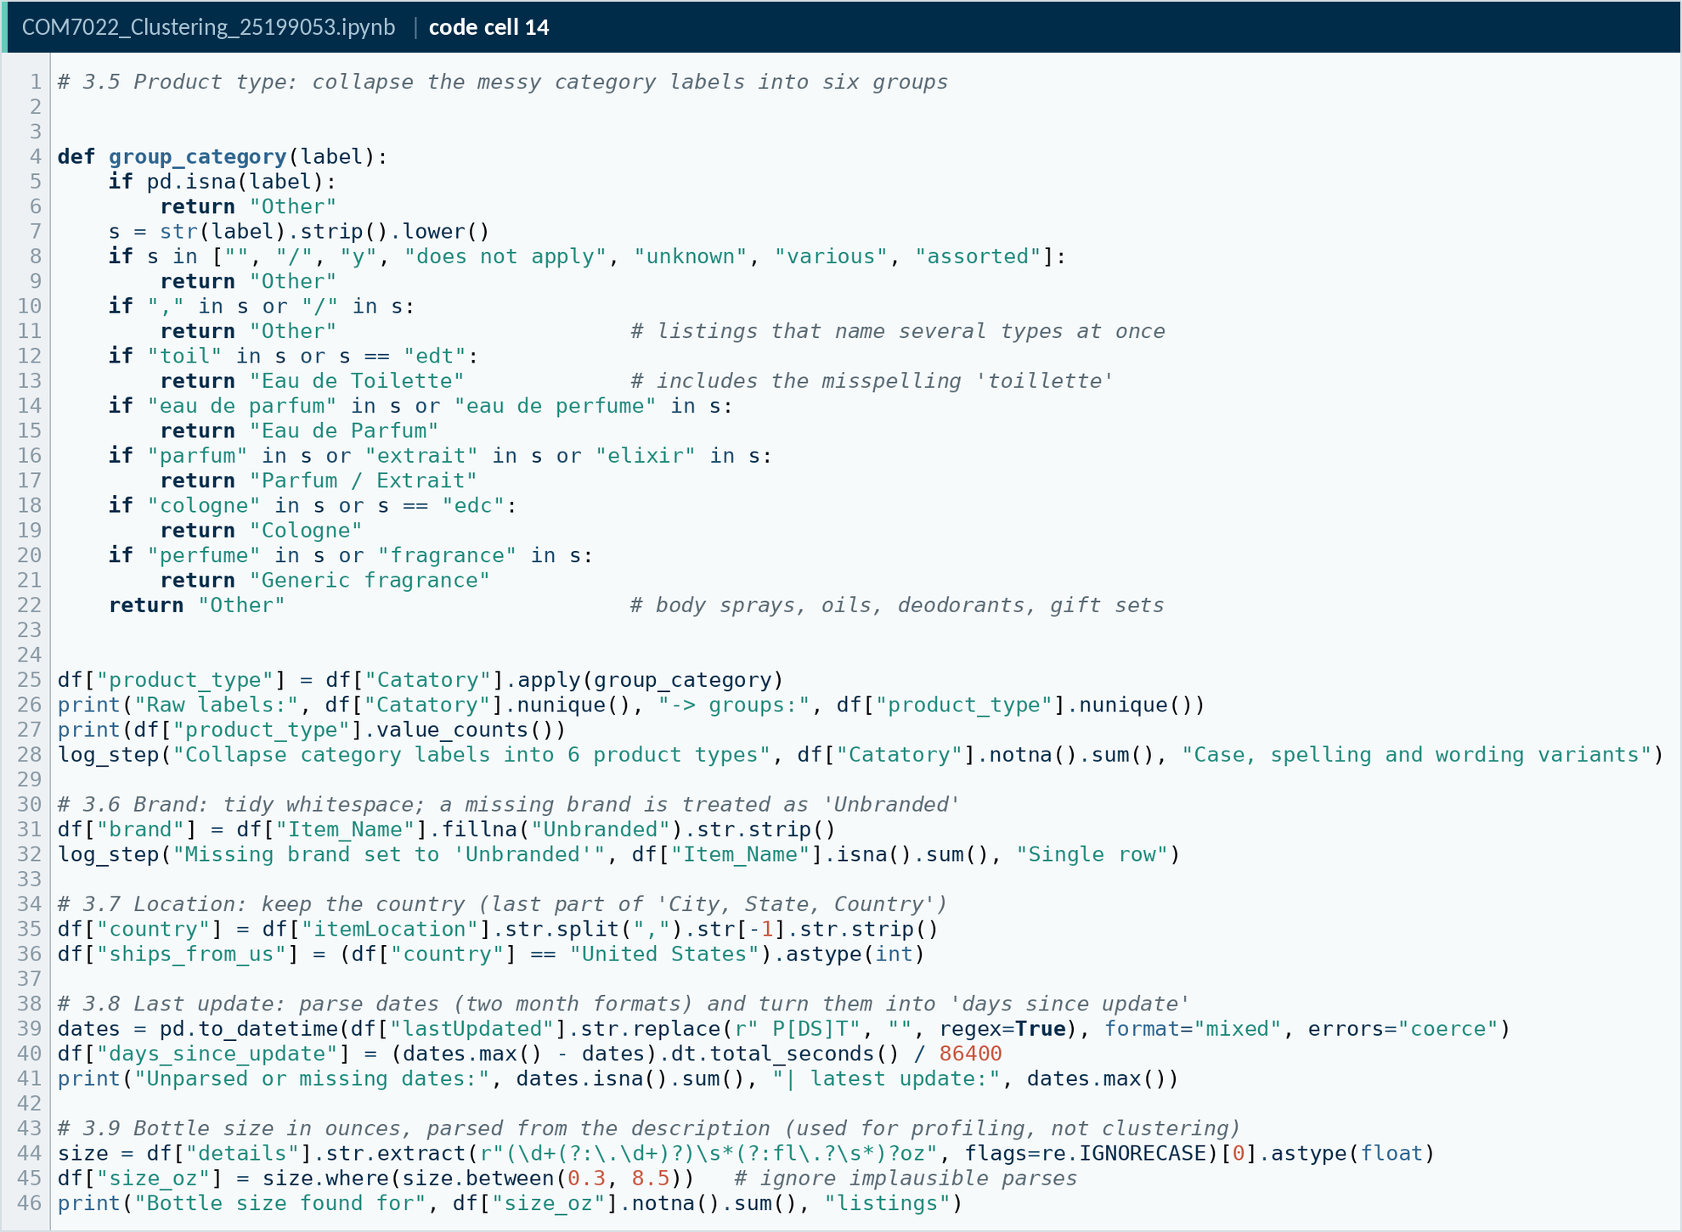
Code A14. Notebook code cell 14
Source: COM7022 - Assignment/output/screenshots/appendix/cell14.png
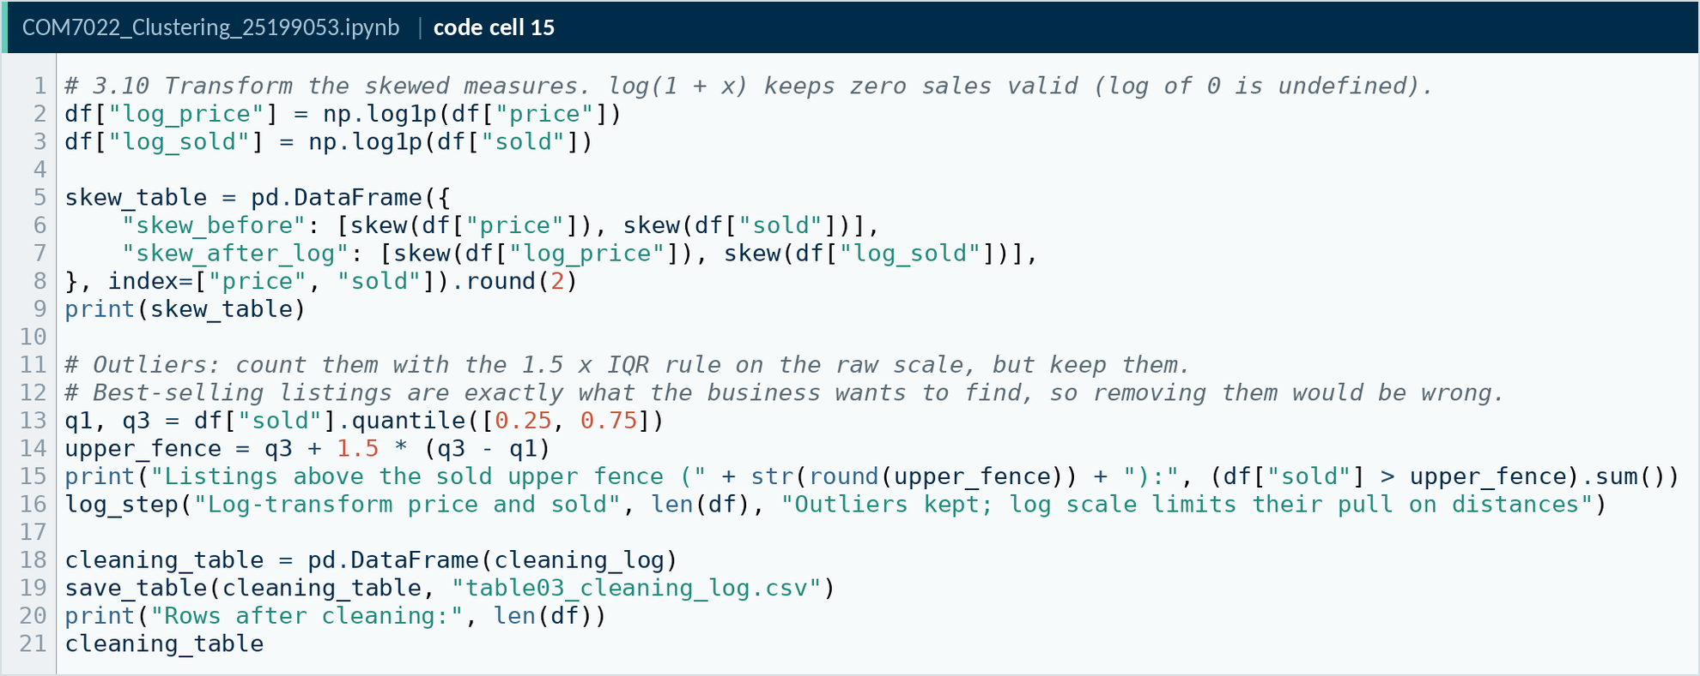
Code A15. Notebook code cell 15
Source: COM7022 - Assignment/output/screenshots/appendix/cell15.png
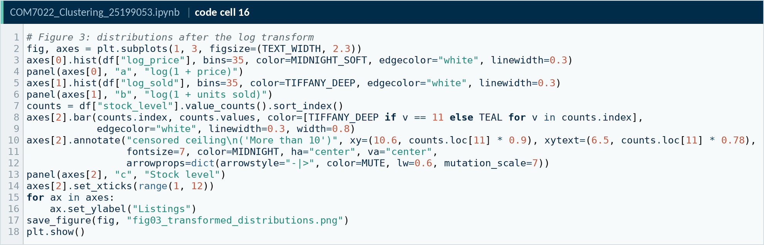
Code A16. Notebook code cell 16
Source: COM7022 - Assignment/output/screenshots/appendix/cell16.png
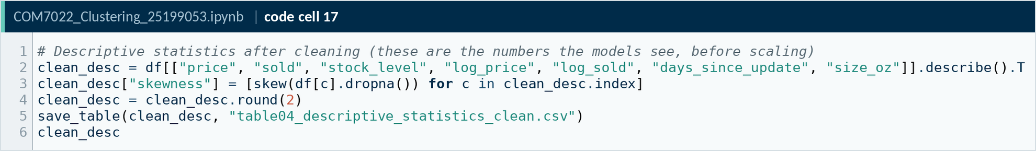
Code A17. Notebook code cell 17
Source: COM7022 - Assignment/output/screenshots/appendix/cell17.png

A · 4. Feature selection
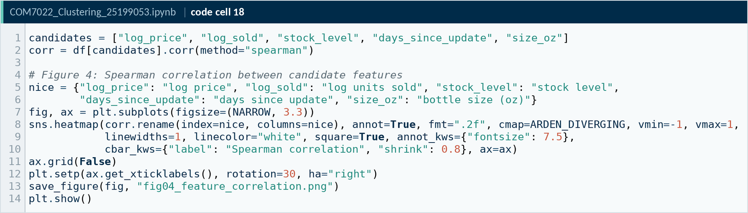
Code A18. Notebook code cell 18
Source: COM7022 - Assignment/output/screenshots/appendix/cell18.png
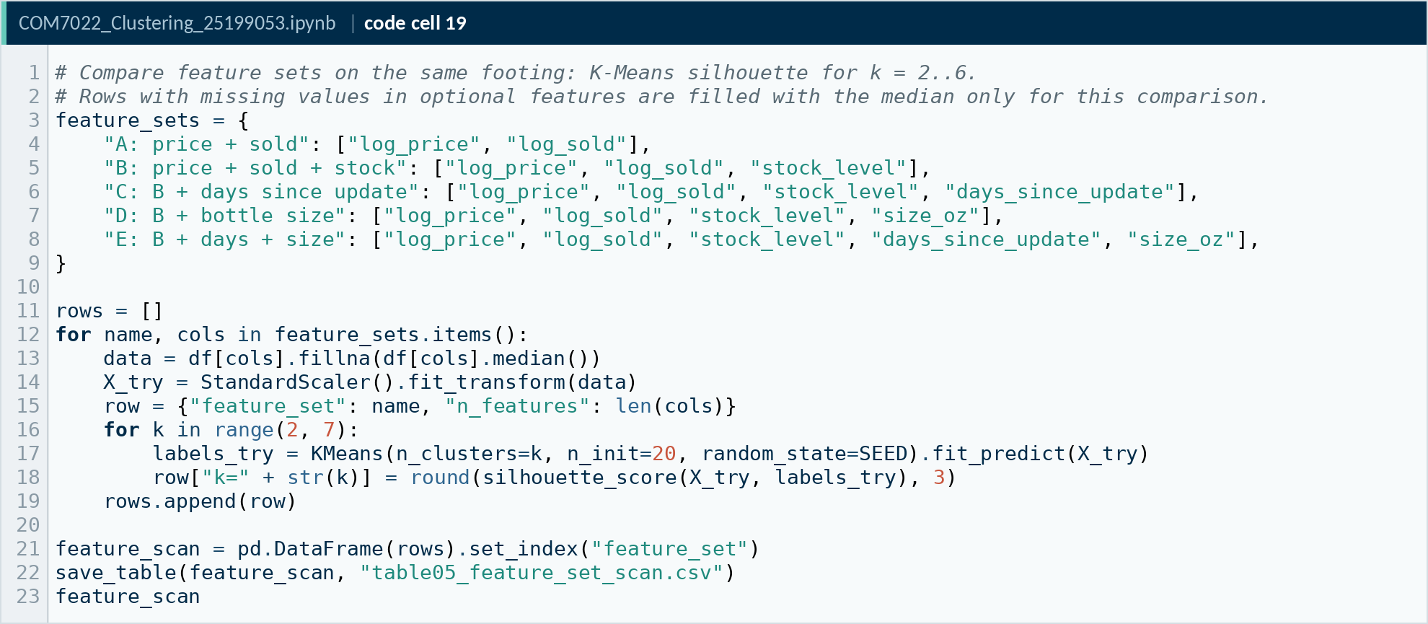
Code A19. Notebook code cell 19
Source: COM7022 - Assignment/output/screenshots/appendix/cell19.png
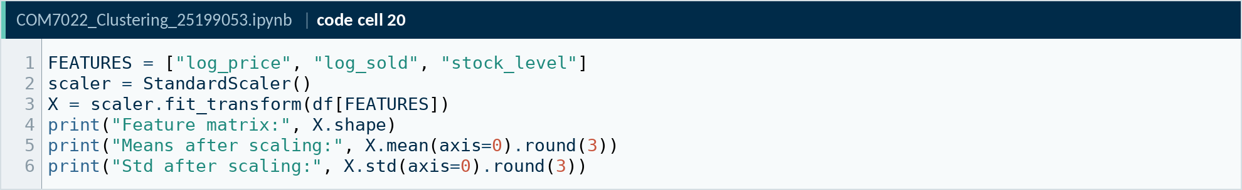
Code A20. Notebook code cell 20
Source: COM7022 - Assignment/output/screenshots/appendix/cell20.png

A · 5. Principal Component Analysis
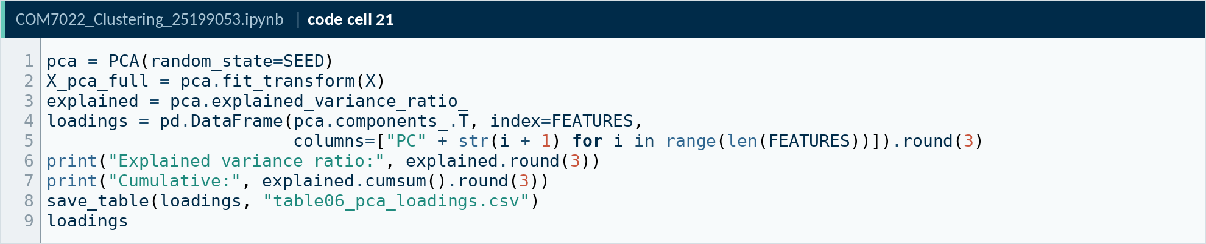
Code A21. Notebook code cell 21
Source: COM7022 - Assignment/output/screenshots/appendix/cell21.png
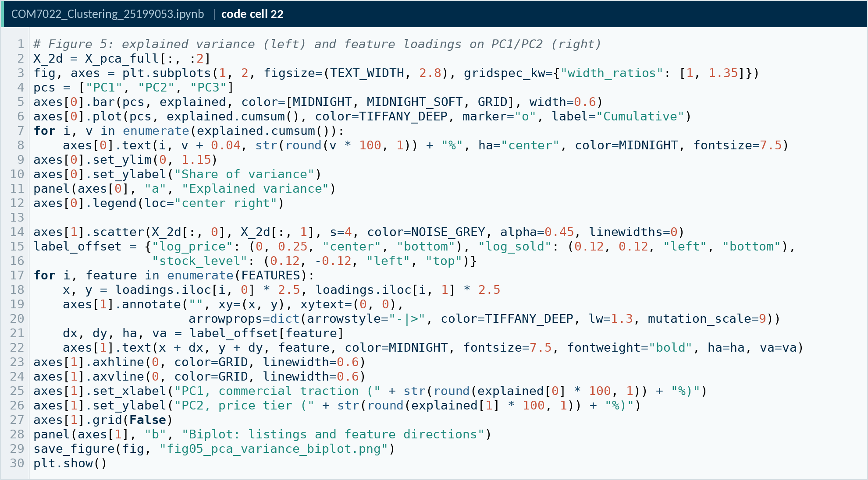
Code A22. Notebook code cell 22
Source: COM7022 - Assignment/output/screenshots/appendix/cell22.png

A · 6. K-Means
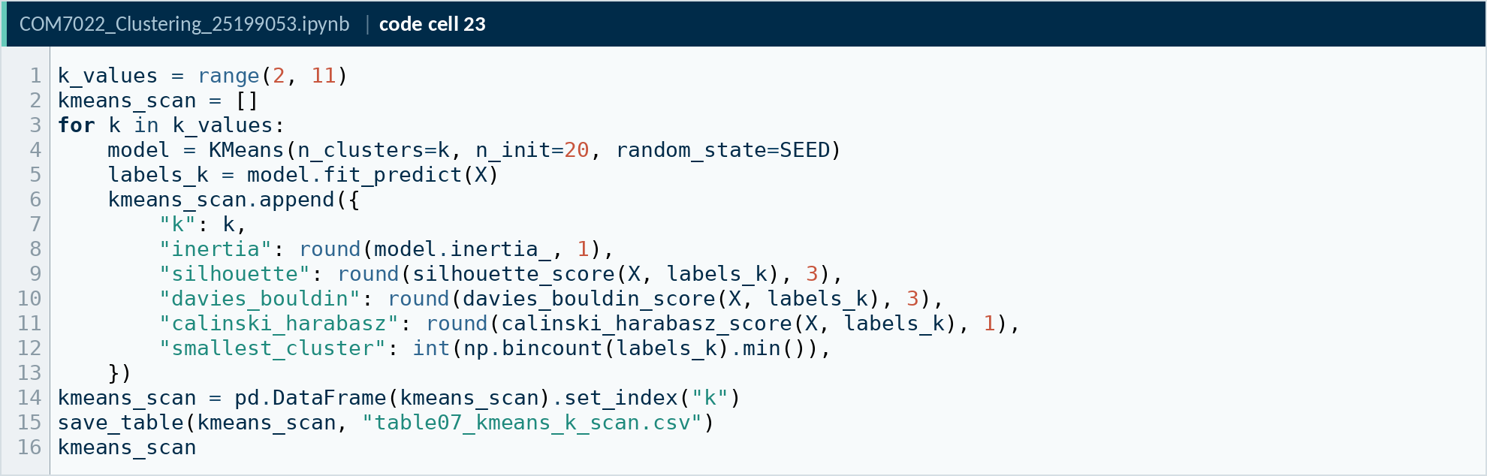
Code A23. Notebook code cell 23
Source: COM7022 - Assignment/output/screenshots/appendix/cell23.png
Code A24. Notebook code cell 24
Source: COM7022 - Assignment/output/screenshots/appendix/cell24.png
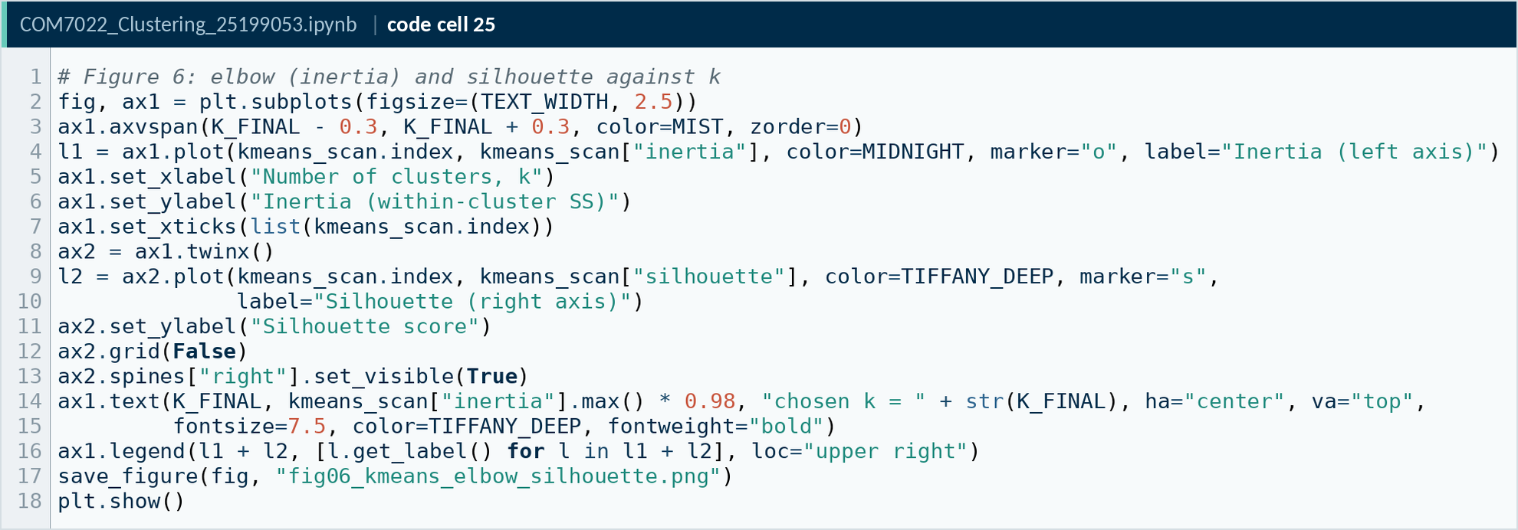
Code A25. Notebook code cell 25
Source: COM7022 - Assignment/output/screenshots/appendix/cell25.png
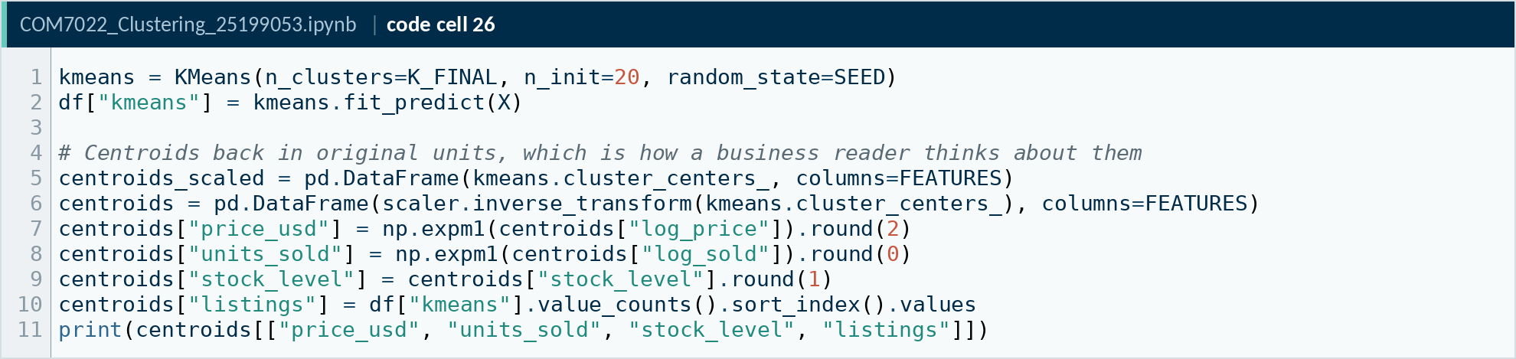
Code A26. Notebook code cell 26
Source: COM7022 - Assignment/output/screenshots/appendix/cell26.png
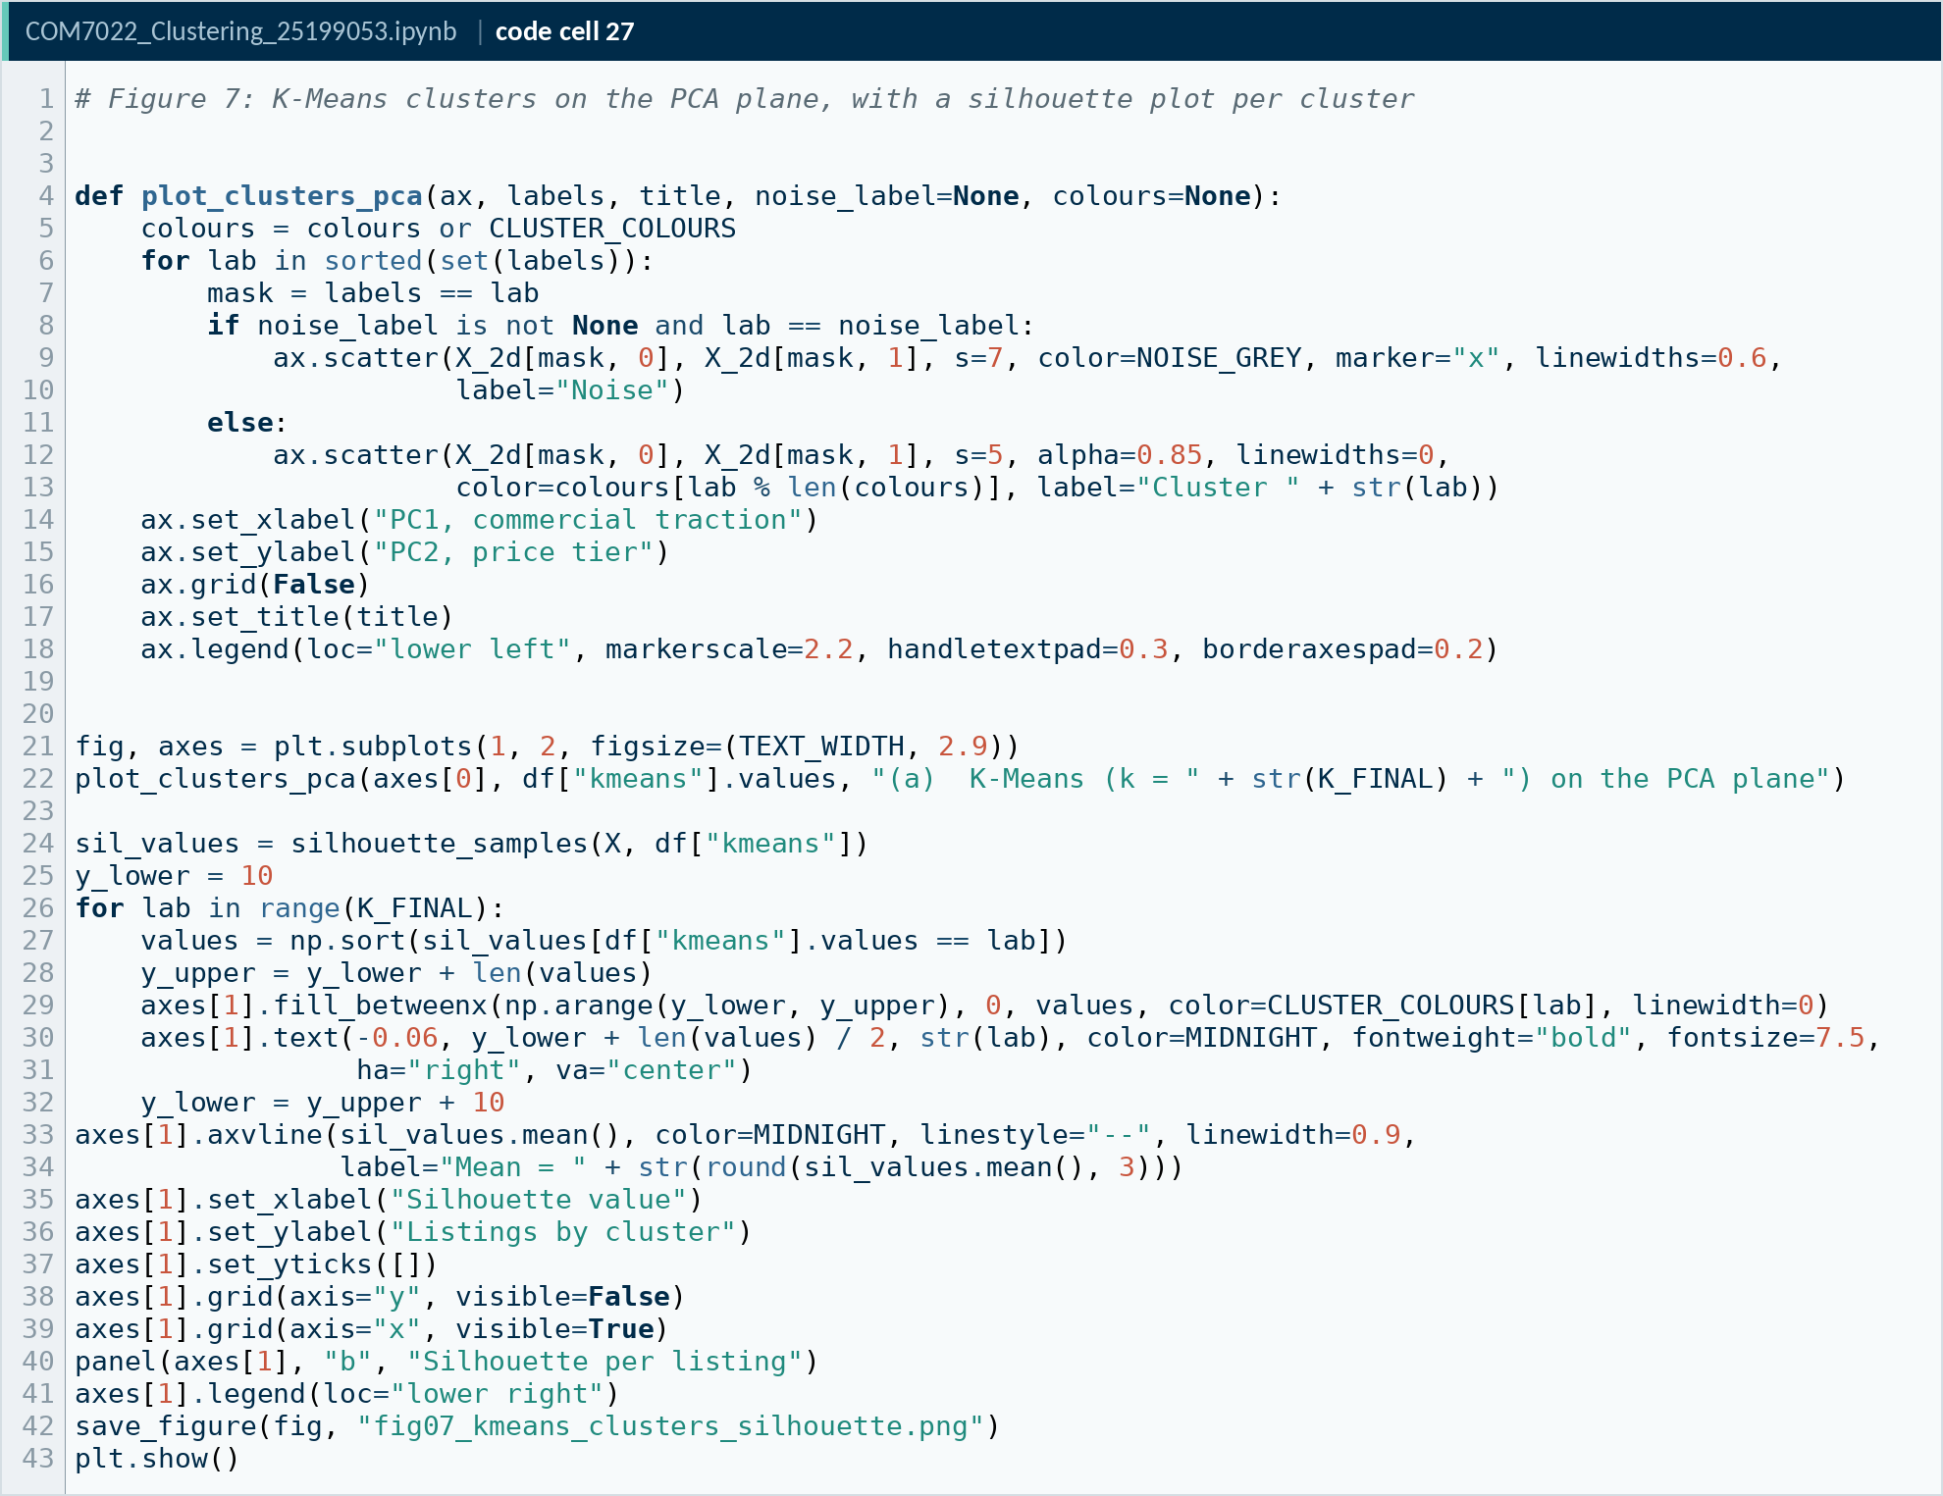
Code A27. Notebook code cell 27
Source: COM7022 - Assignment/output/screenshots/appendix/cell27.png

A · 7. Hierarchical clustering
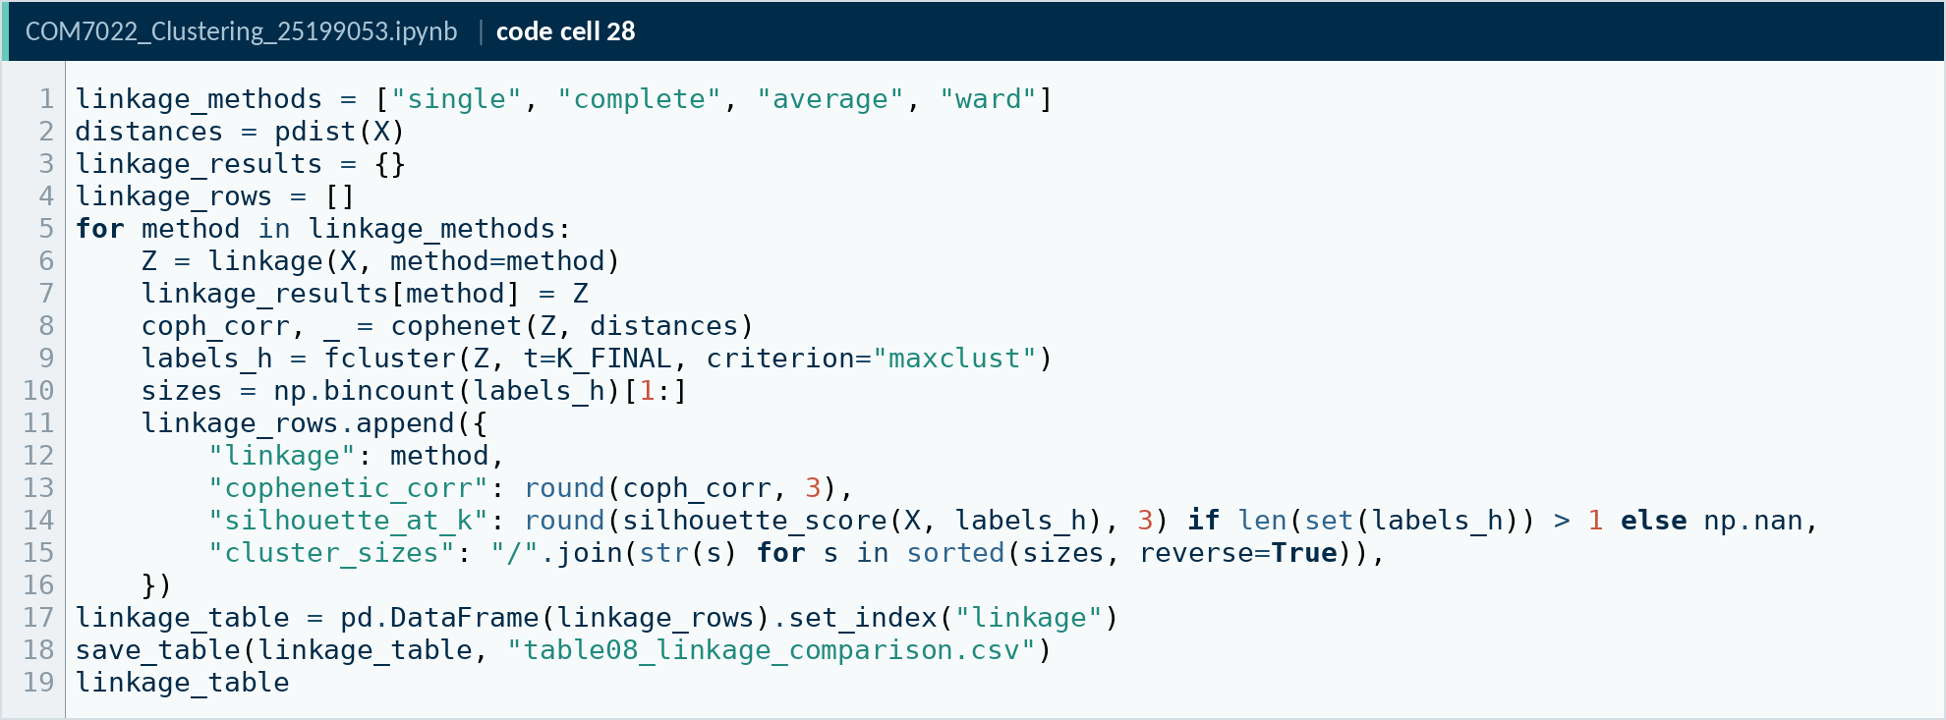
Code A28. Notebook code cell 28
Source: COM7022 - Assignment/output/screenshots/appendix/cell28.png
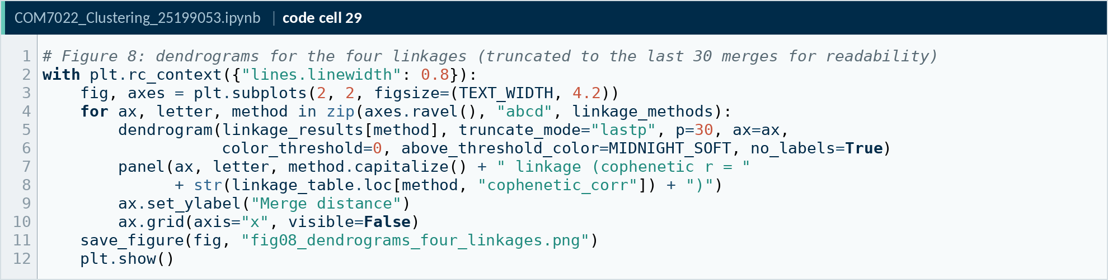
Code A29. Notebook code cell 29
Source: COM7022 - Assignment/output/screenshots/appendix/cell29.png
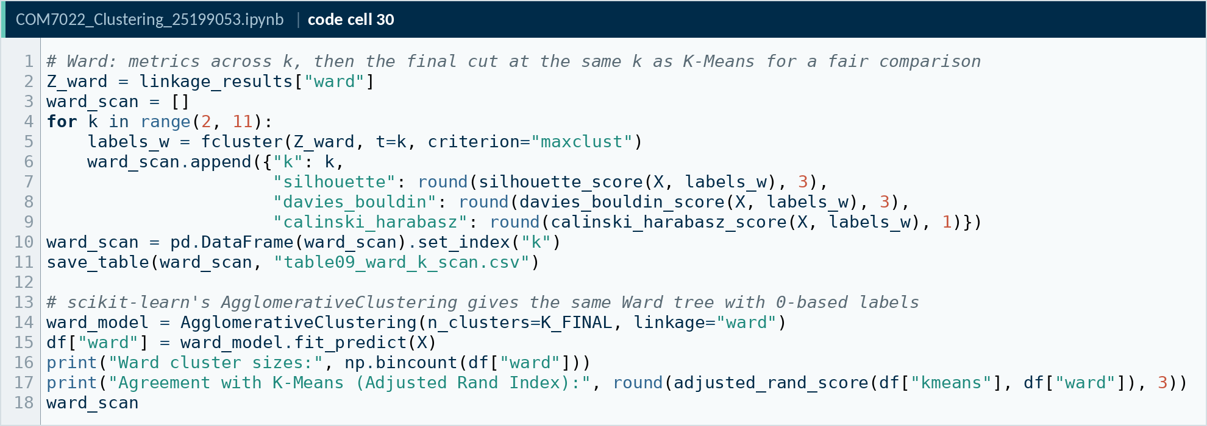
Code A30. Notebook code cell 30
Source: COM7022 - Assignment/output/screenshots/appendix/cell30.png
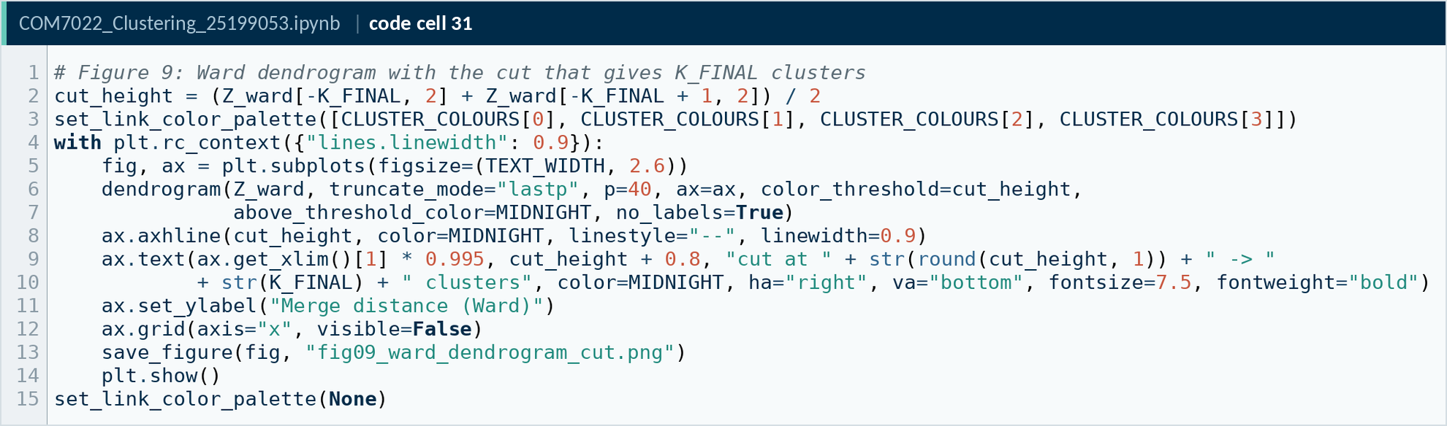
Code A31. Notebook code cell 31
Source: COM7022 - Assignment/output/screenshots/appendix/cell31.png

A · 8. DBSCAN
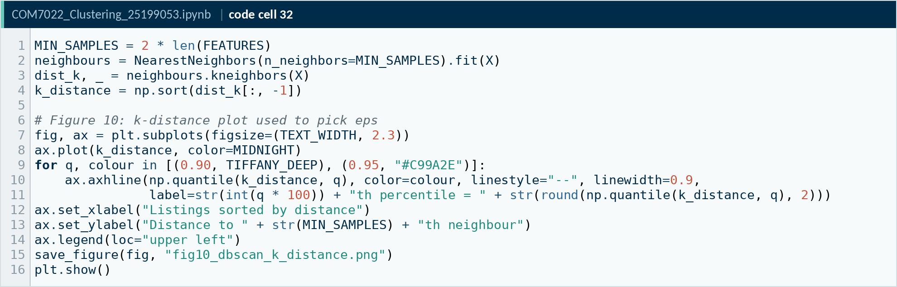
Code A32. Notebook code cell 32
Source: COM7022 - Assignment/output/screenshots/appendix/cell32.png
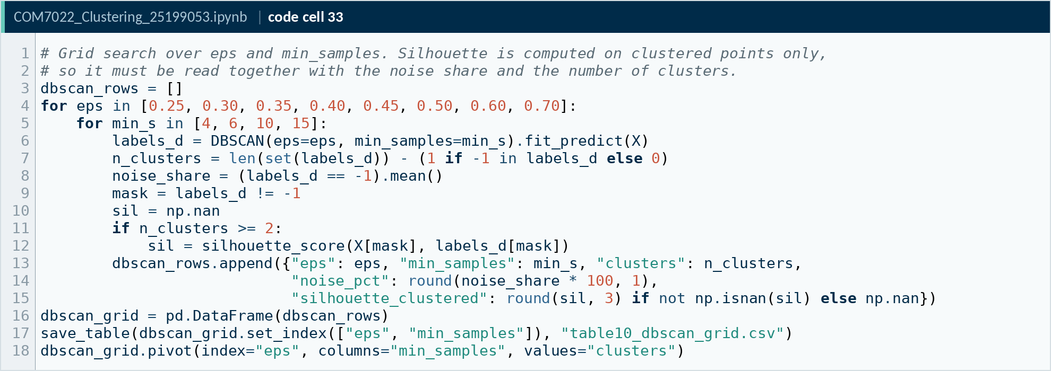
Code A33. Notebook code cell 33
Source: COM7022 - Assignment/output/screenshots/appendix/cell33.png
Code A34. Notebook code cell 34
Source: COM7022 - Assignment/output/screenshots/appendix/cell34.png
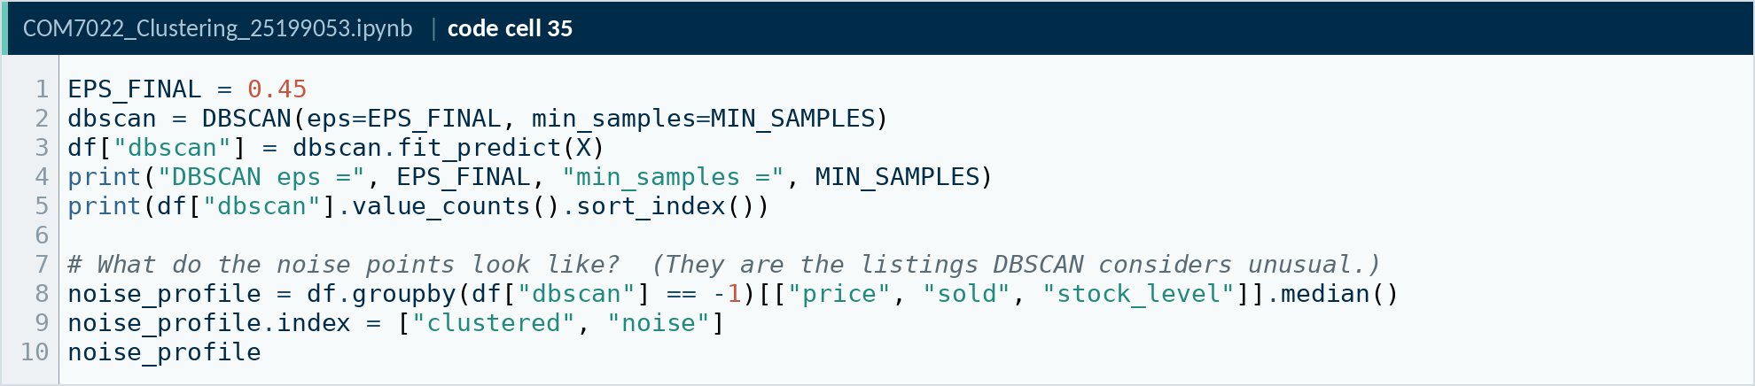
Code A35. Notebook code cell 35
Source: COM7022 - Assignment/output/screenshots/appendix/cell35.png
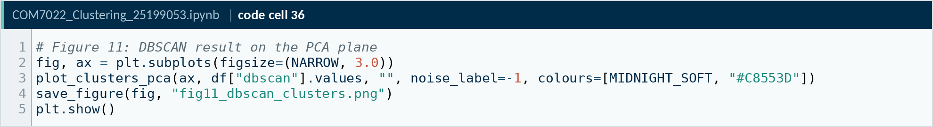
Code A36. Notebook code cell 36
Source: COM7022 - Assignment/output/screenshots/appendix/cell36.png

A · 9. HDBSCAN
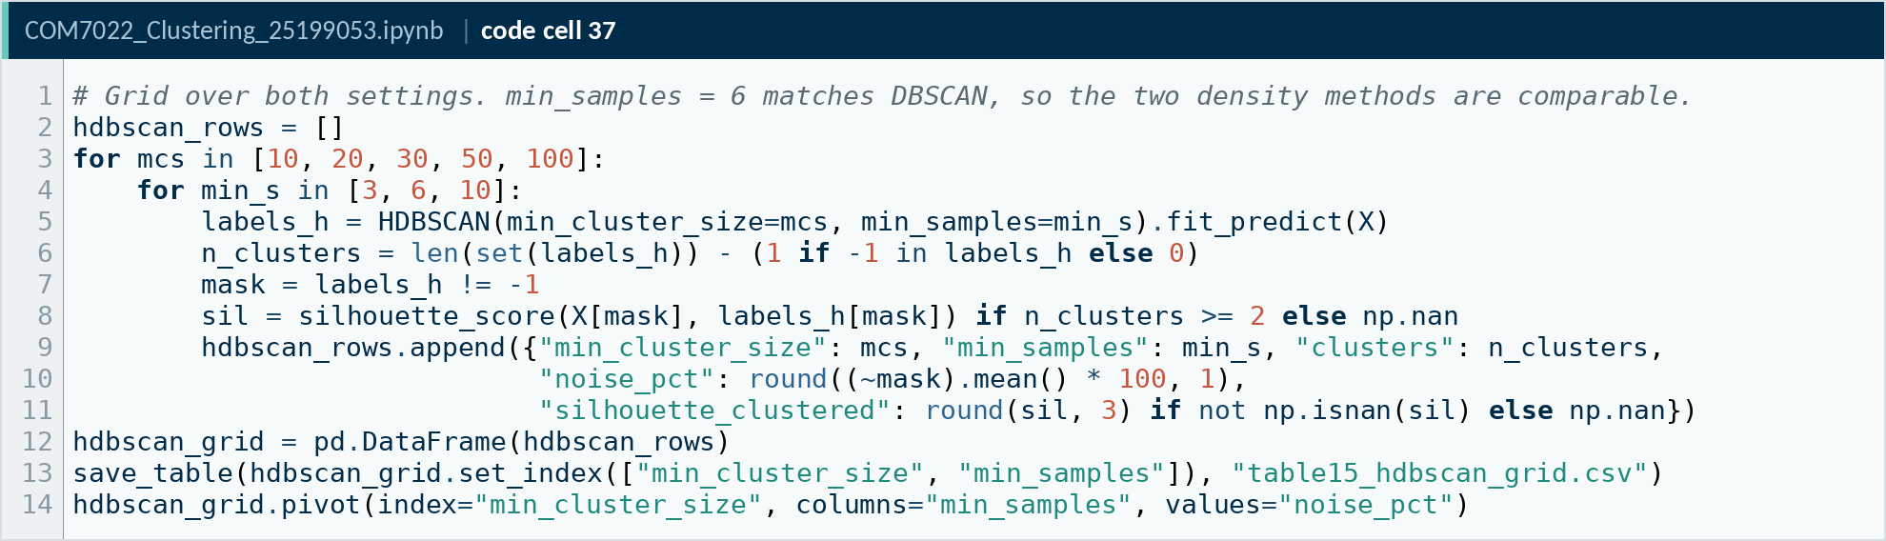
Code A37. Notebook code cell 37
Source: COM7022 - Assignment/output/screenshots/appendix/cell37.png
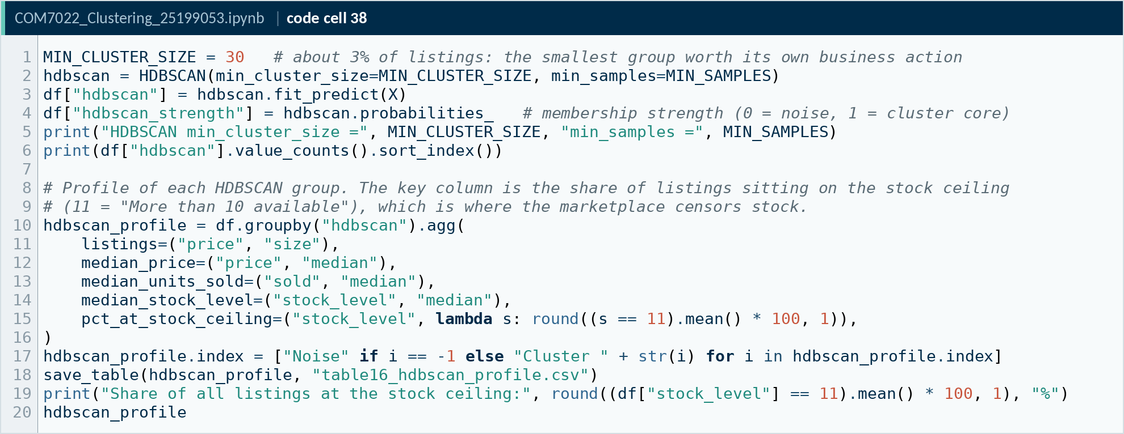
Code A38. Notebook code cell 38
Source: COM7022 - Assignment/output/screenshots/appendix/cell38.png
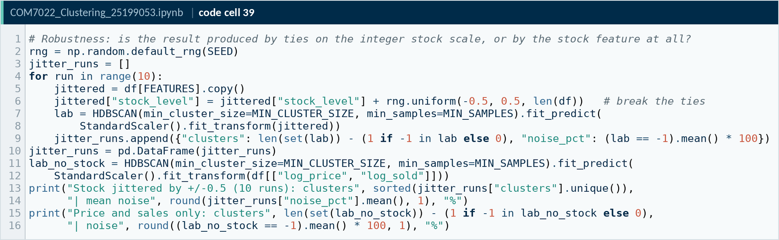
Code A39. Notebook code cell 39
Source: COM7022 - Assignment/output/screenshots/appendix/cell39.png
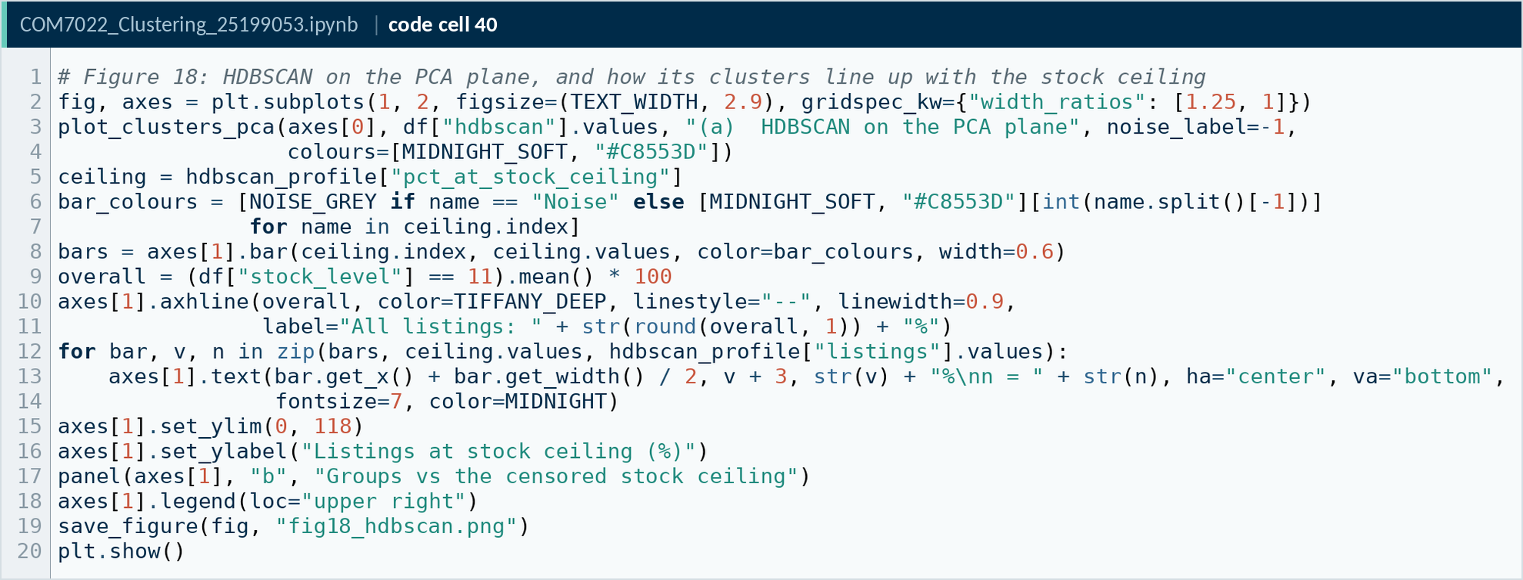
Code A40. Notebook code cell 40
Source: COM7022 - Assignment/output/screenshots/appendix/cell40.png

A · 10. TabClustPFN (tabular foundation model)
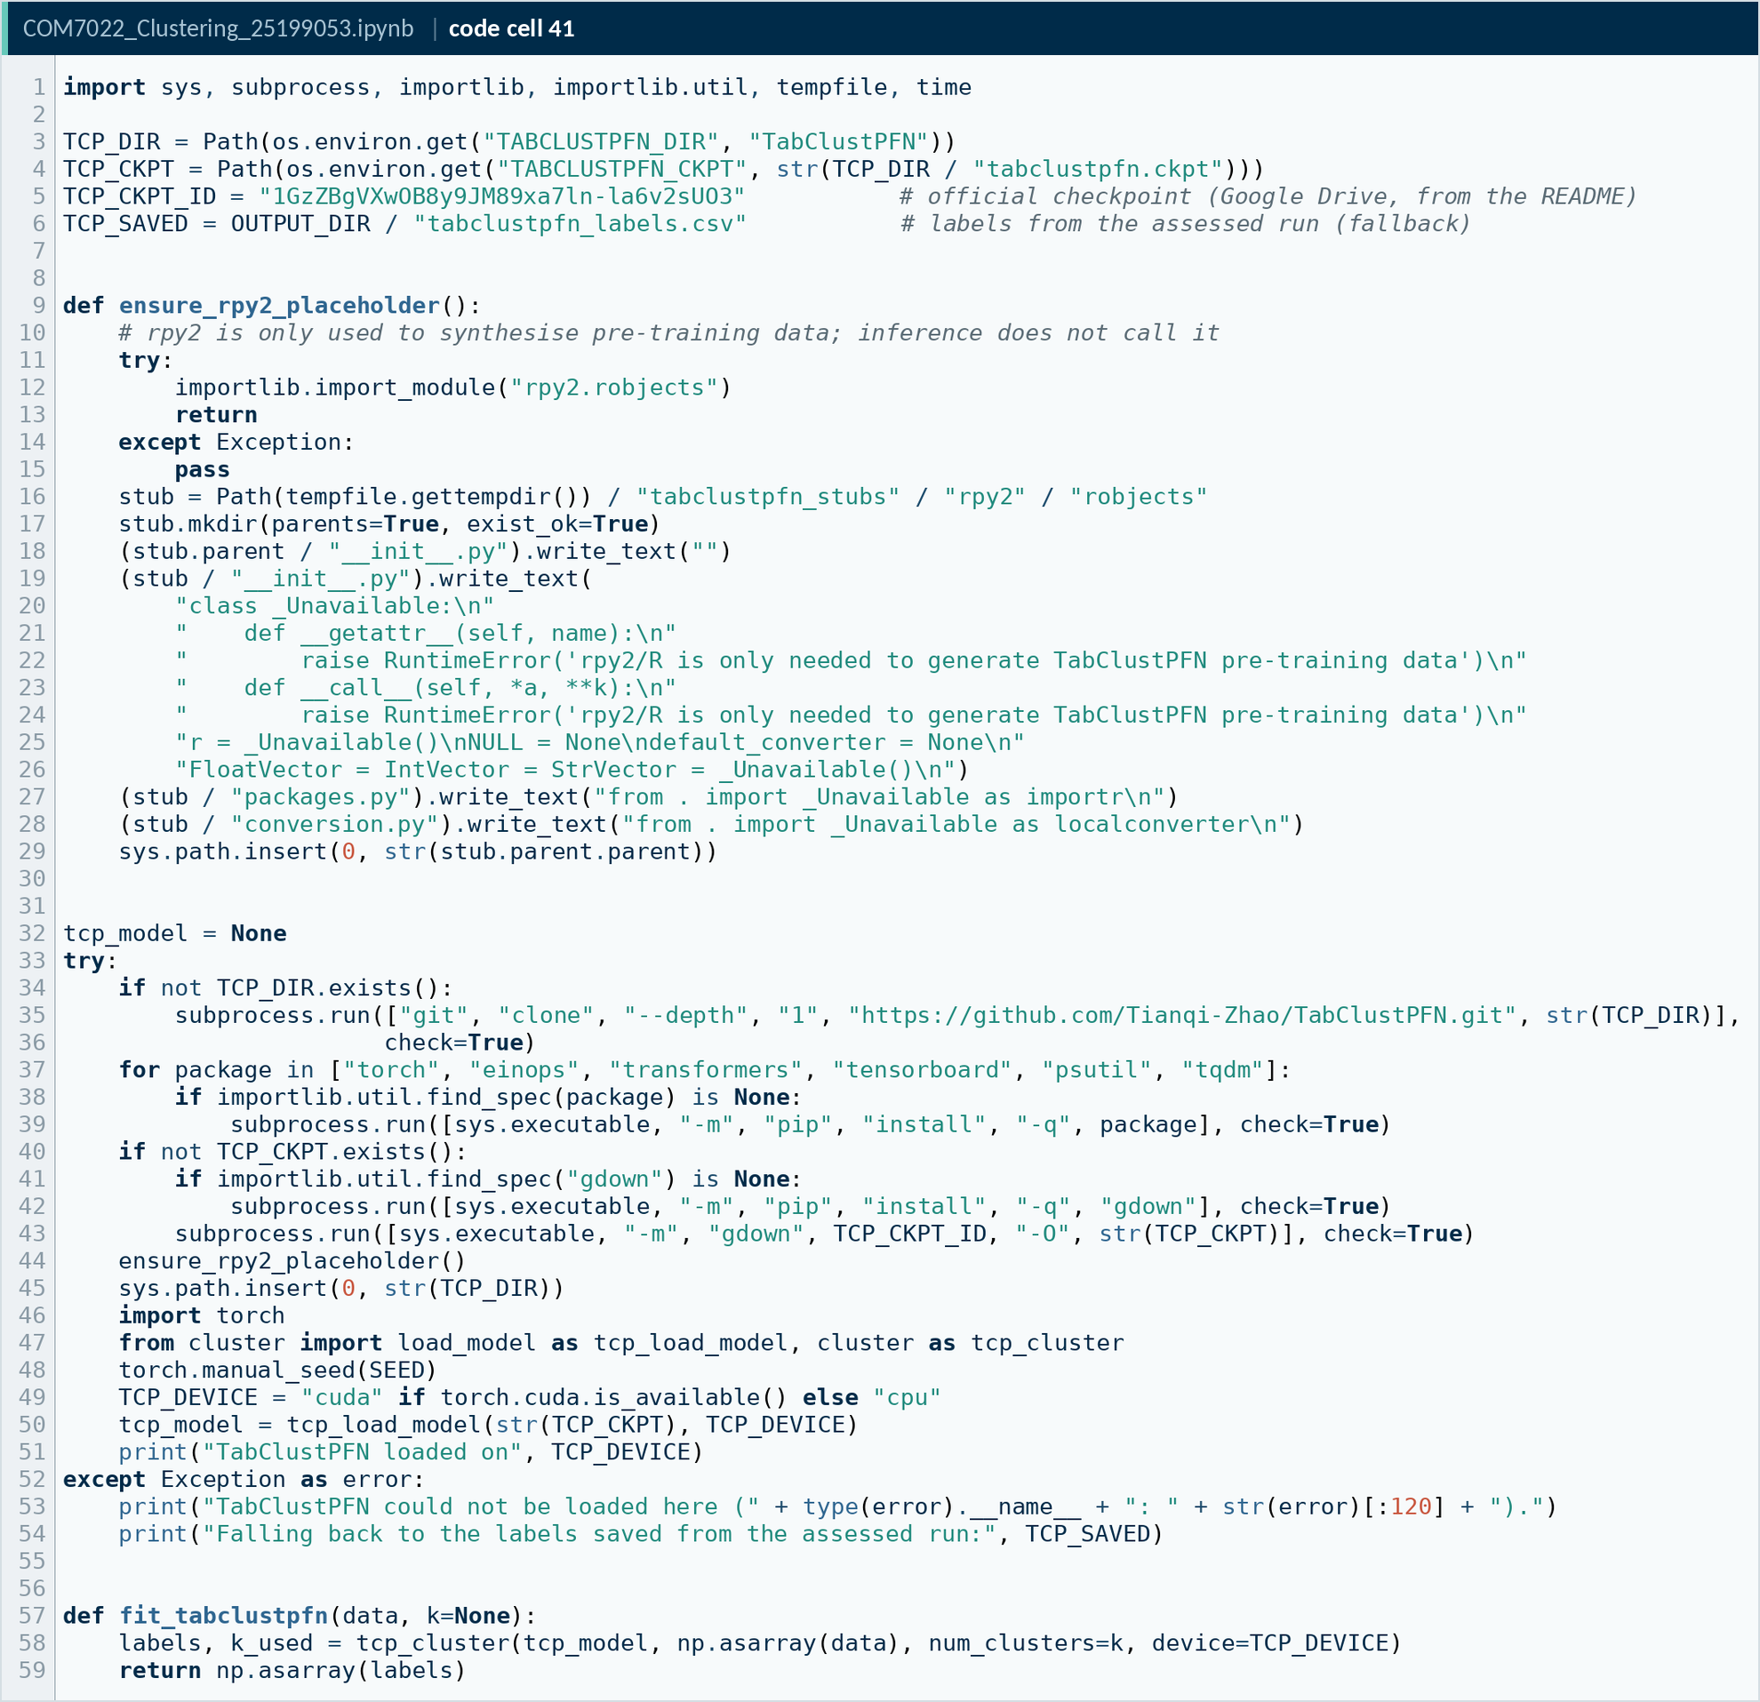
Code A41. Notebook code cell 41
Source: COM7022 - Assignment/output/screenshots/appendix/cell41.png
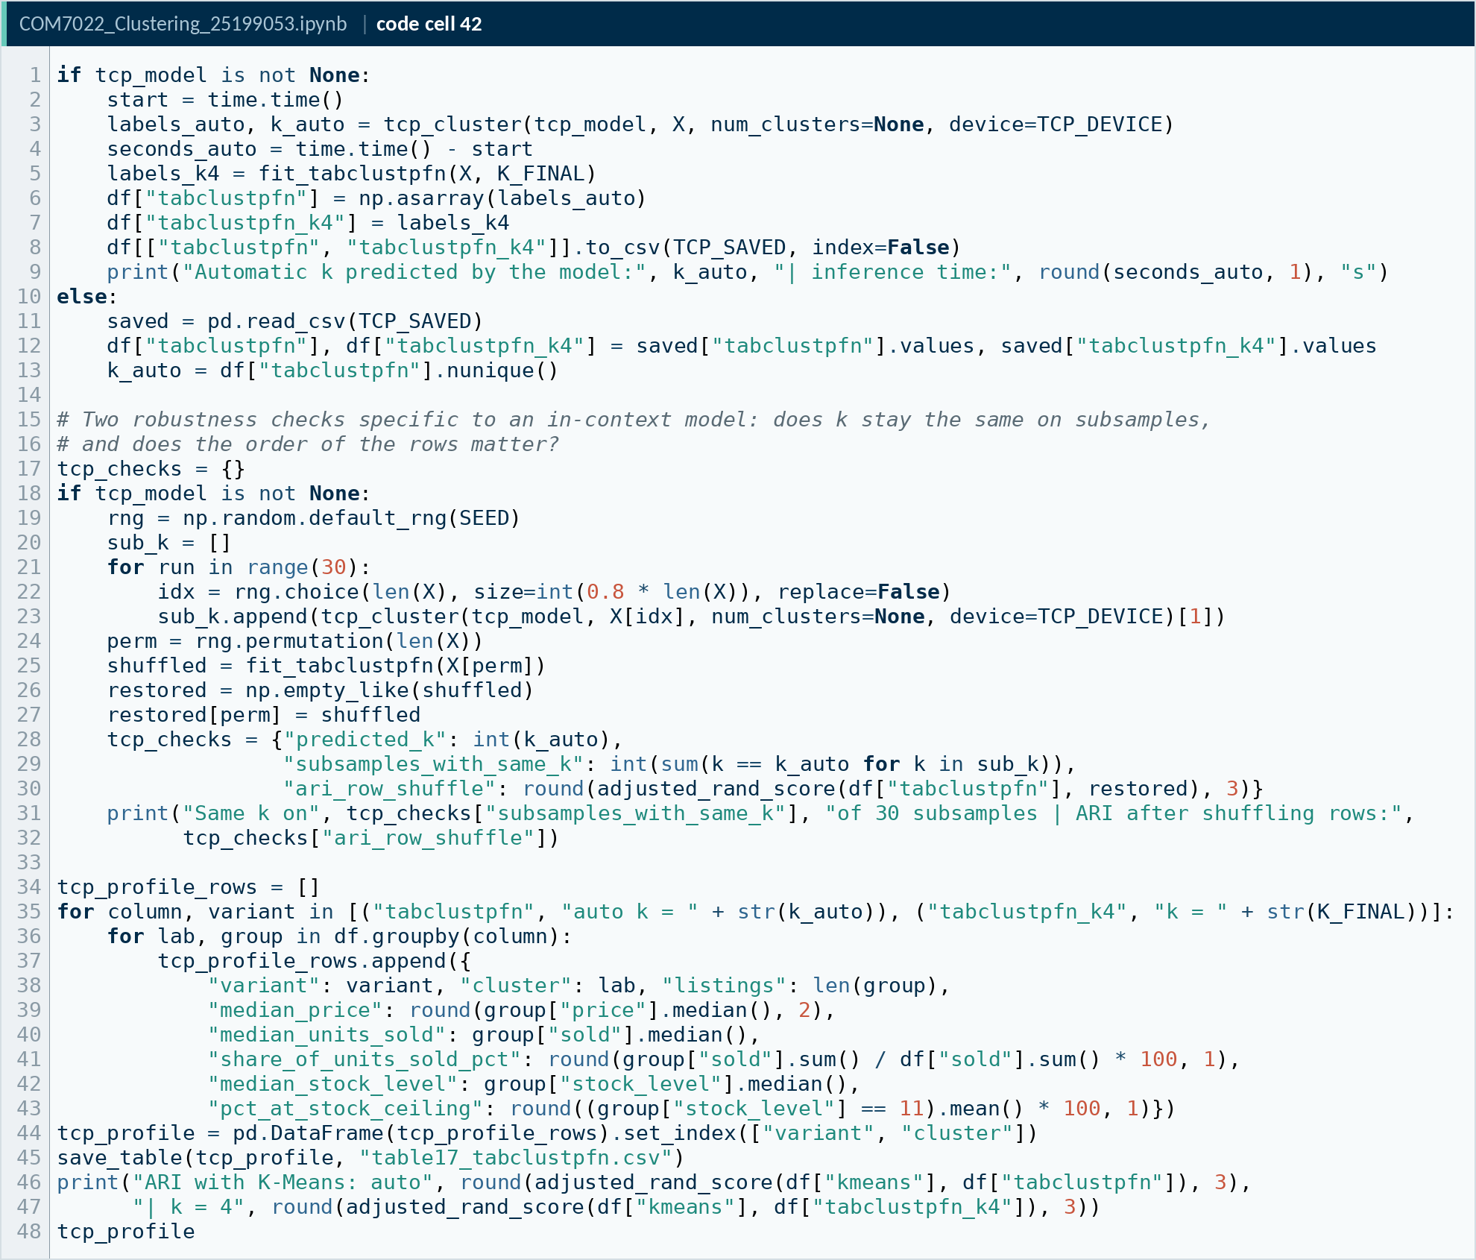
Code A42. Notebook code cell 42
Source: COM7022 - Assignment/output/screenshots/appendix/cell42.png
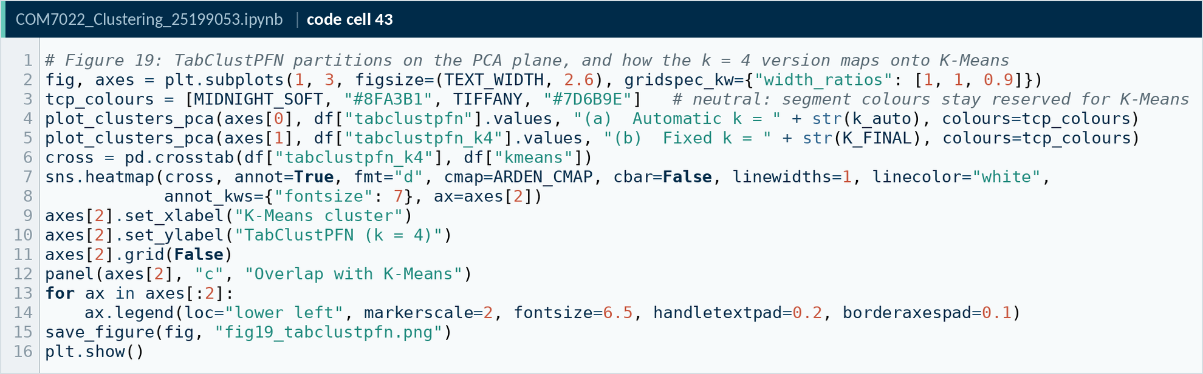
Code A43. Notebook code cell 43
Source: COM7022 - Assignment/output/screenshots/appendix/cell43.png

A · 11. Model comparison and validation
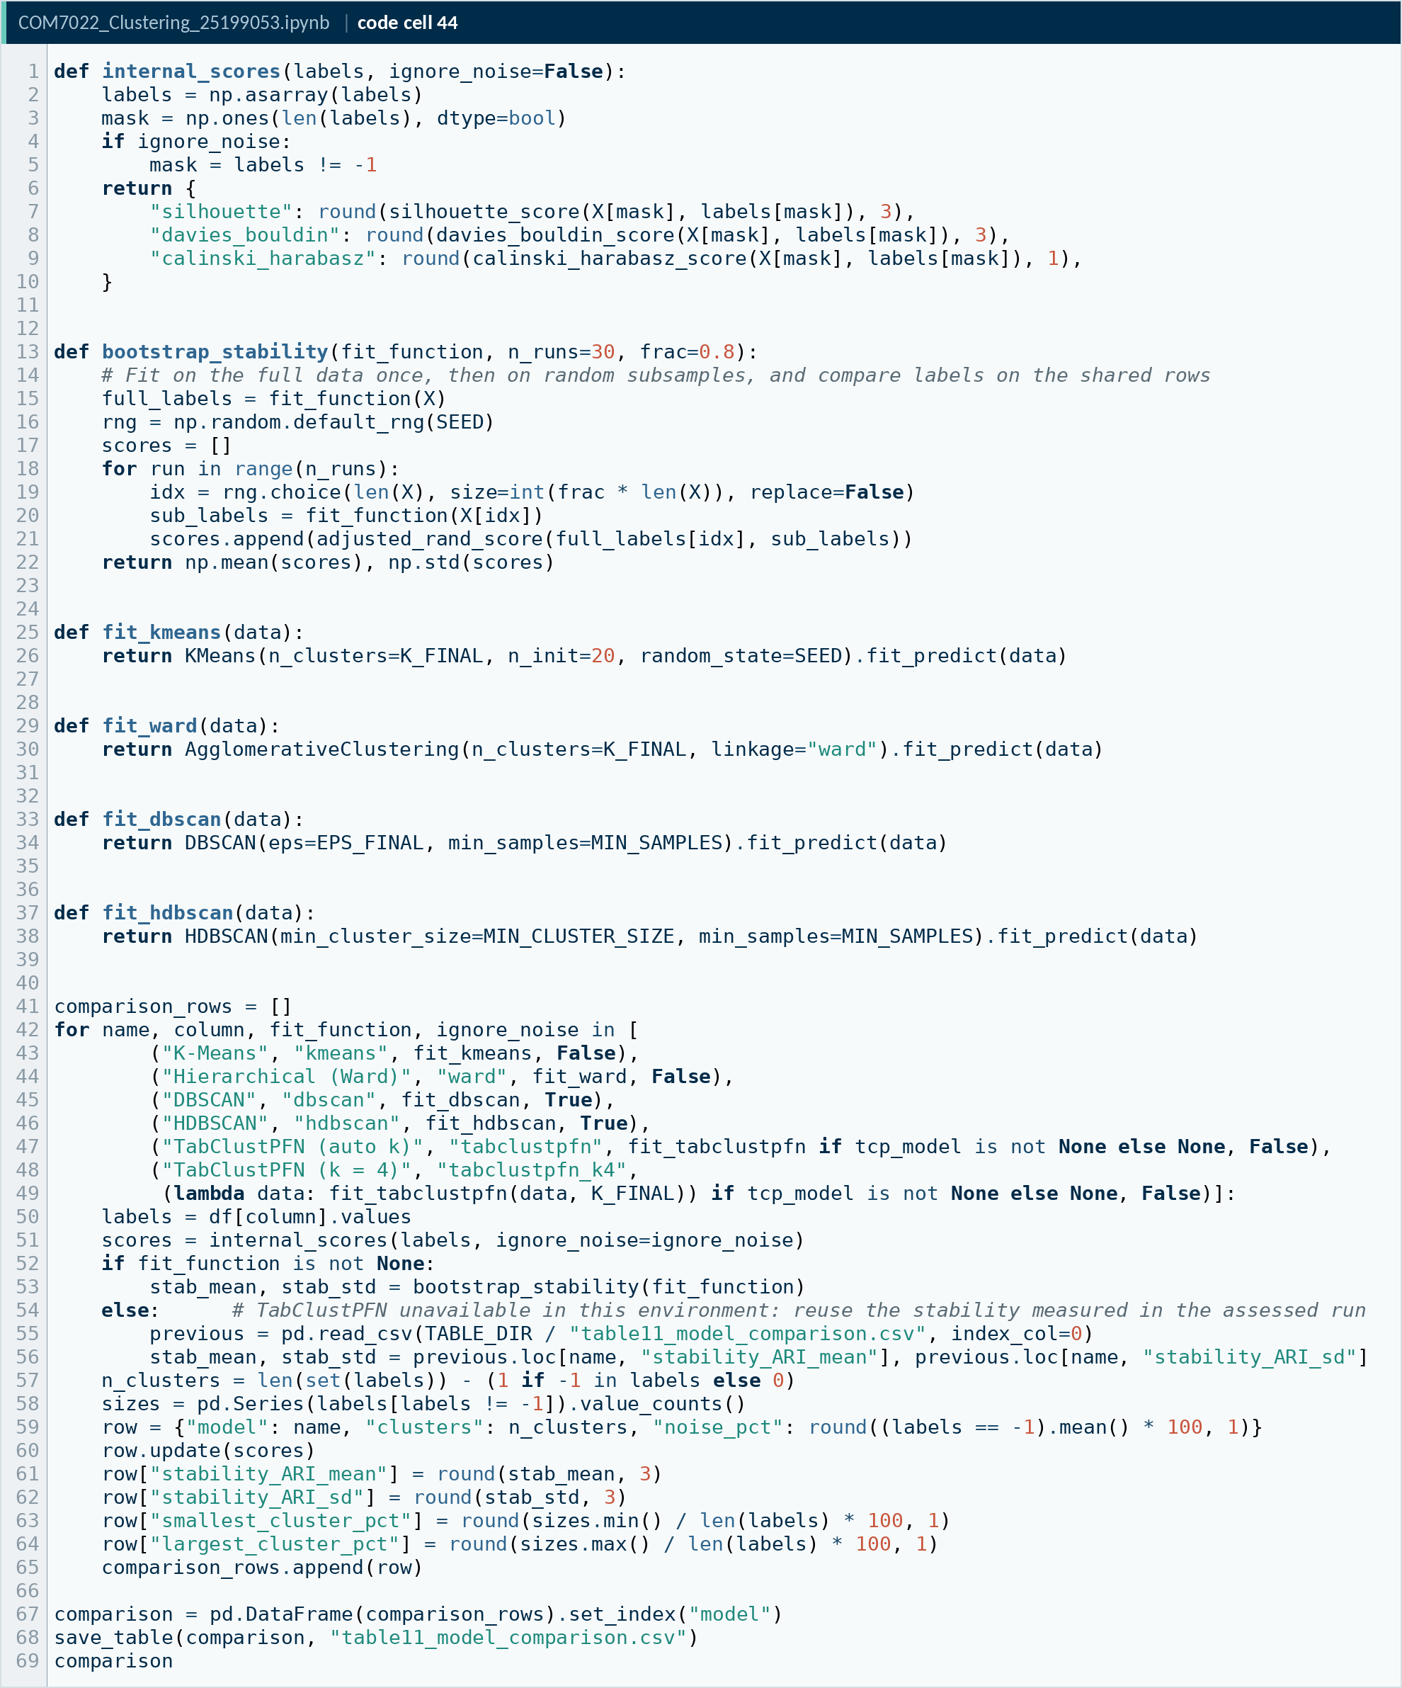
Code A44. Notebook code cell 44
Source: COM7022 - Assignment/output/screenshots/appendix/cell44.png
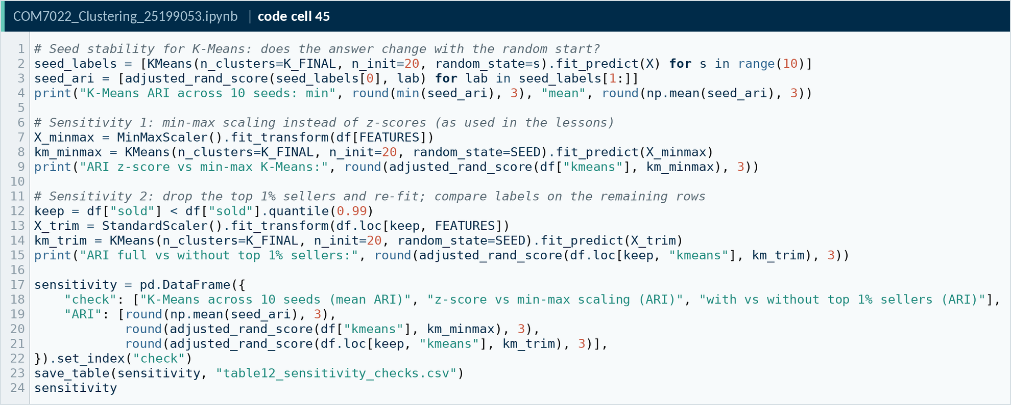
Code A45. Notebook code cell 45
Source: COM7022 - Assignment/output/screenshots/appendix/cell45.png
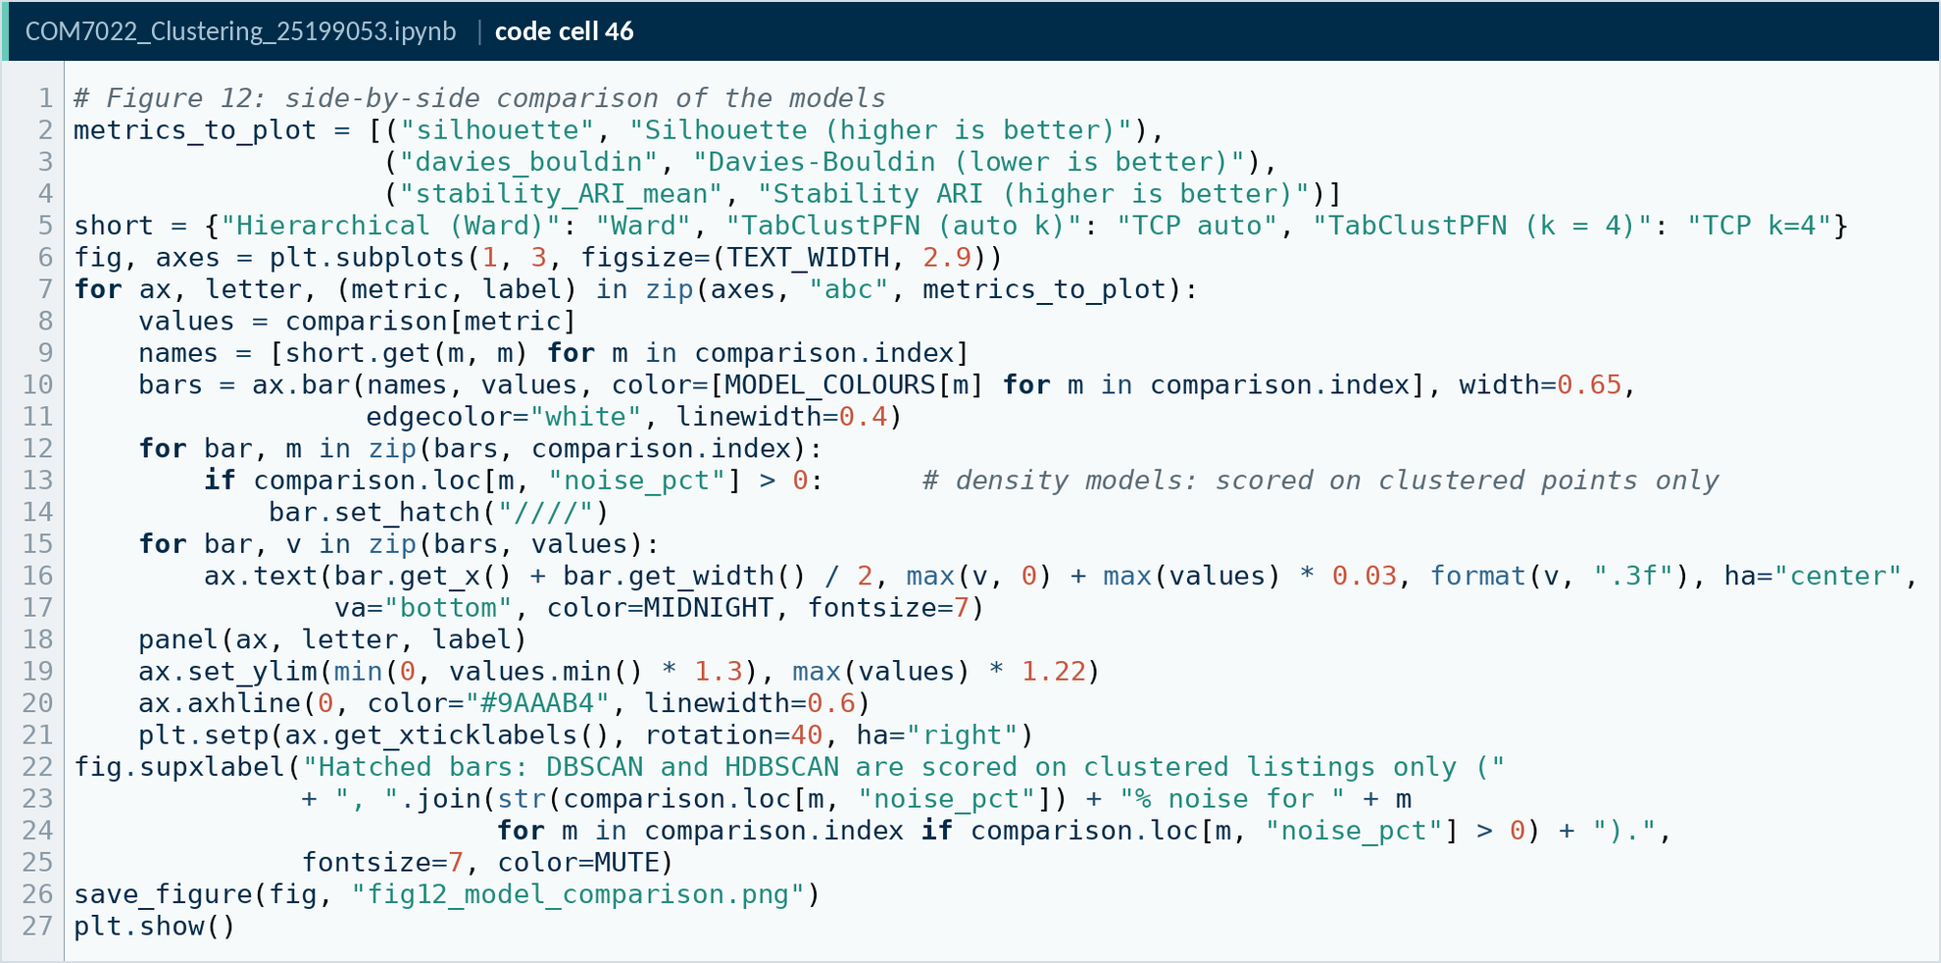
Code A46. Notebook code cell 46
Source: COM7022 - Assignment/output/screenshots/appendix/cell46.png

A · 12. Final model and cluster profiles
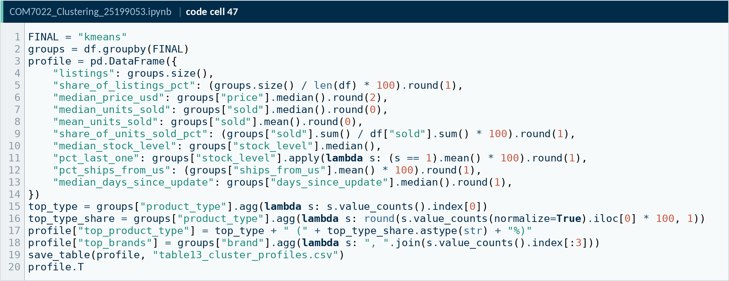
Code A47. Notebook code cell 47
Source: COM7022 - Assignment/output/screenshots/appendix/cell47.png
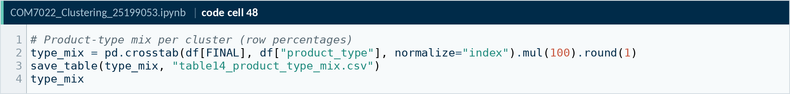
Code A48. Notebook code cell 48
Source: COM7022 - Assignment/output/screenshots/appendix/cell48.png
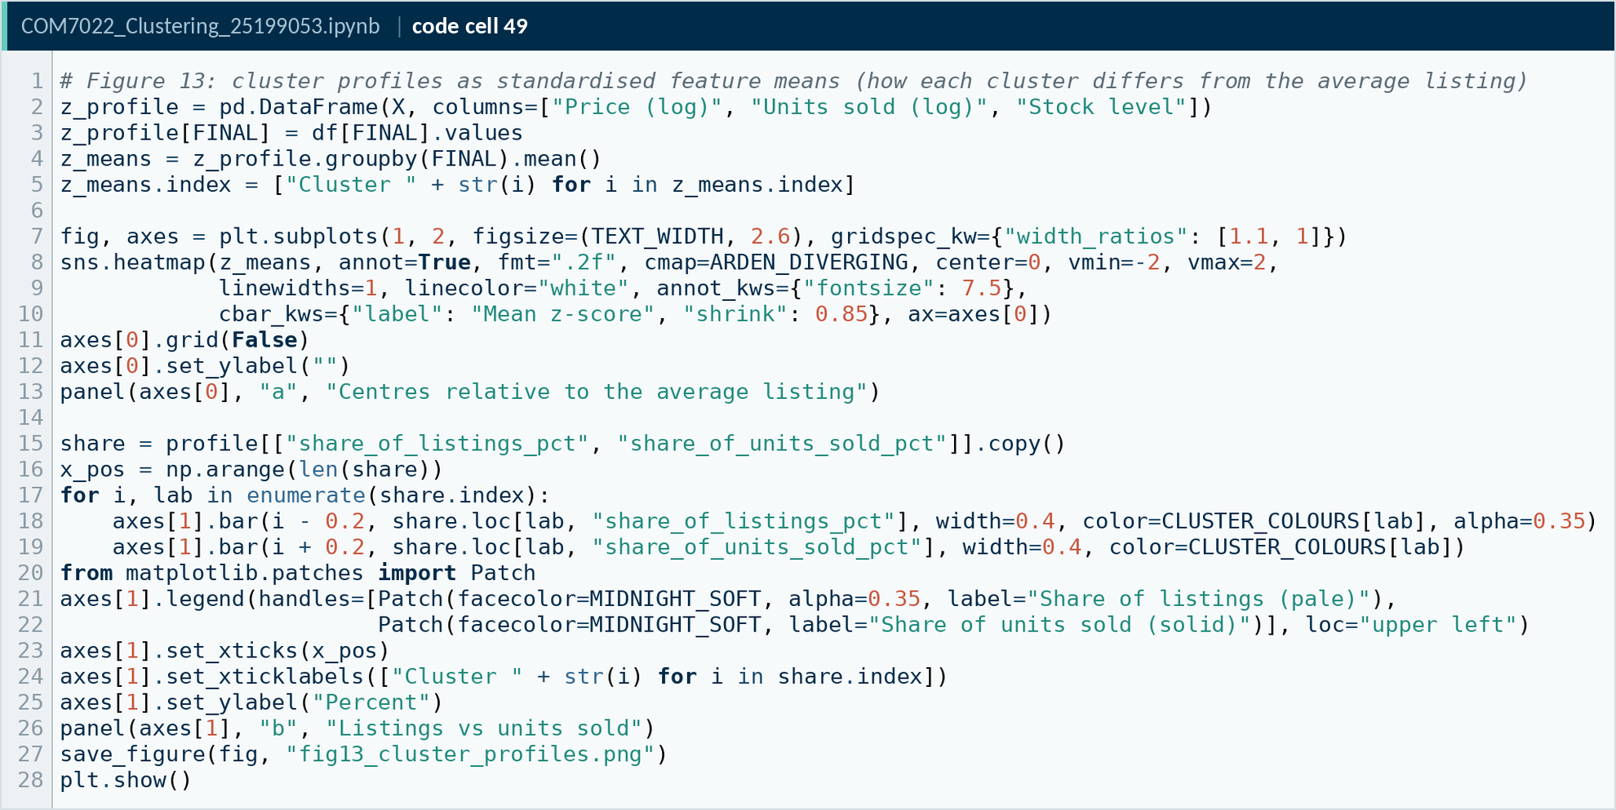
Code A49. Notebook code cell 49
Source: COM7022 - Assignment/output/screenshots/appendix/cell49.png
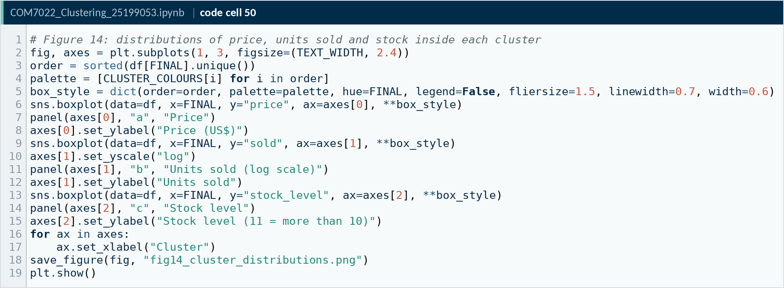
Code A50. Notebook code cell 50
Source: COM7022 - Assignment/output/screenshots/appendix/cell50.png
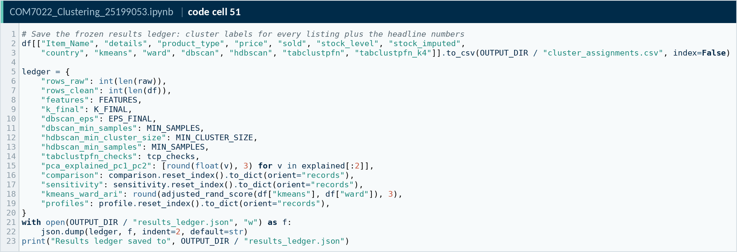
Code A51. Notebook code cell 51
Source: COM7022 - Assignment/output/screenshots/appendix/cell51.png
AI use declaration. AI tools were used to support structuring and proofreading. All analysis was executed, verified and interpreted by the author, and every reported figure was checked against the notebook output. (Align wording with the Arden AI policy before submission.)

